Co-op Connect Training
Promotions
How to create a flat packed FSDU on Co-op Connect
Co-op Connect Training
Free Standing Display Unit (FSDU) – Flat packed
Contents
Co-op Connect training – Create a flat packed free standing display unit (FSDU) 3
1.0. Create a new flat packed FSDU - Key fields/ things to know 3
1.1. Article Details (1st) tab 3
1.2. Basic Data (2nd tab) 4
1.3. Unit of Measure (4th) tab 4
2.0. Create a new flat packed FSDU – full guide 5
2.1. Create Article – Article details 5
2.2. Create Article - Basic Data 8
2.3. Create Article – Life of Product 11
2.4. Create article – Restrictions 12
2.5. Create Article - Unit of Measure 12
Reminder of Terms 13
2.6.1. Examples of how the screen will look once the units have been created for a flat packed FSDU 14
2.6.2. Add Unit of Measure Pop Up 15
2.6.3. Unit of Measure – finished example 20
2.7. Create Article – Purchasing Details 21
3.0. View Create article change request 23
Key points/ Top tips 23
3.1. Homepage 23
3.2. My Change Requests 24
3.3. Extracted Form 26

Co-op Connect training – Create a flat packed free standing display unit (FSDU)

What is a flat packed FSDU? – a free standing display unit that is ordered and distributed without any articles.

This training guide will show the details of:
- Creating a flat packed FSDU through the Create Article function
- Viewing article change requests

1.0. Create a new flat packed FSDU - Key fields/ things to know
The process for creating an FSDU is the same as creating a new article, however there are specific options in some fields that will need to be selected depending on whether the FSDU is flat packed or pre/partially filled. If these fields are completed and submitted incorrectly, it may lead to the change request being rejected and the Vendor having to start a new CR from scratch.
When creating an FSDU (pre filled or flat packed) on Co-op Connect, no article information needs to be included. The articles that will be advertised on the FSDUs in store will be added/tagged to the FSDU internally.

1.1. Article Details (1st) tab

- Merchandising Category – If an FSDU is being created, the merchandising category that is selected will need to have ‘FSDU’ included in the name, for example:

If the FSDU specific merchandising category is not selected, the FSDU will be set up incorrectly.
Once a merchandising category has been selected and the form is submitted for approval, this field cannot be changed. If the wrong merchandising category is chosen the user will have to start the process of creating the FSDU from the beginning.

- Article Category – For a flat packed FSDU, the option that needs to be selected in the article category field is 00 – Single Article, as shown below:

- Article Template – For a flat packed FSDU, the option that needs to be selected in the article template field is “Flat Packed Free-Standing Display Unit (FSDU)”, as shown below:
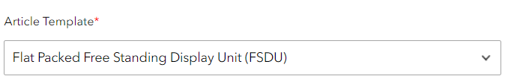

1.2. Basic Data (2nd tab)

- Selling unit size – The selling unit size for an FSDU should only be selected as ‘Each’ or ‘Unit’, as shown below:

1.3. Unit of Measure (4th) tab

- Units – For a flat packed FSDU, the only unit(s) that need to be created are:
- For Depot delivered flat packed FSDUs – Each, Layer, Pallet
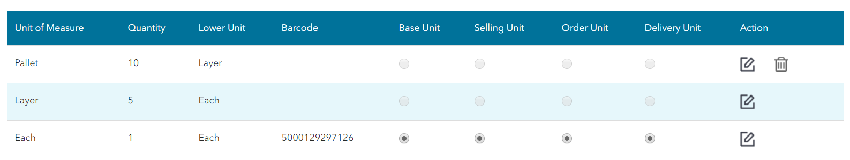

- For direct-to-store flat packed FSDUs – Each

- Dimensions – The dimensions of the FSDU should be entered as if it were flat packed, NOT built (the shipped dimensions). These dimensions are needed so the Co-op know how to store the FSDU.

- Barcode – The barcode that is either entered (for branded FSDUs) or requested (for Co-op branded FSDUs) for the ‘Each’ should be the barcode of the actual FSDU. This will be the barcode that the Co-op use to order the FSDU.

- Unit flagging – The ‘Each’ unit will need to categorised as all of the different types of units – base, selling, order and delivery.

The above points outline the key points and fields that are needed for creating a flat packed FSDU. The rest of this guide shows more information and mimics the Create Article guide with the FSDU amends.

2.0. Create a new flat packed FSDU – full guide
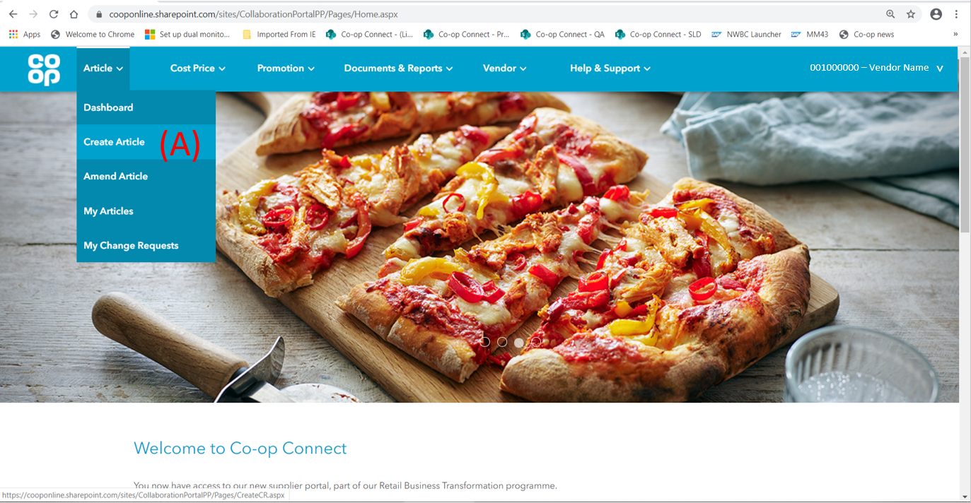
- Click on the ‘Create Article’ option from the ‘Article’ menu in the main header

2.1. Create Article – Article details
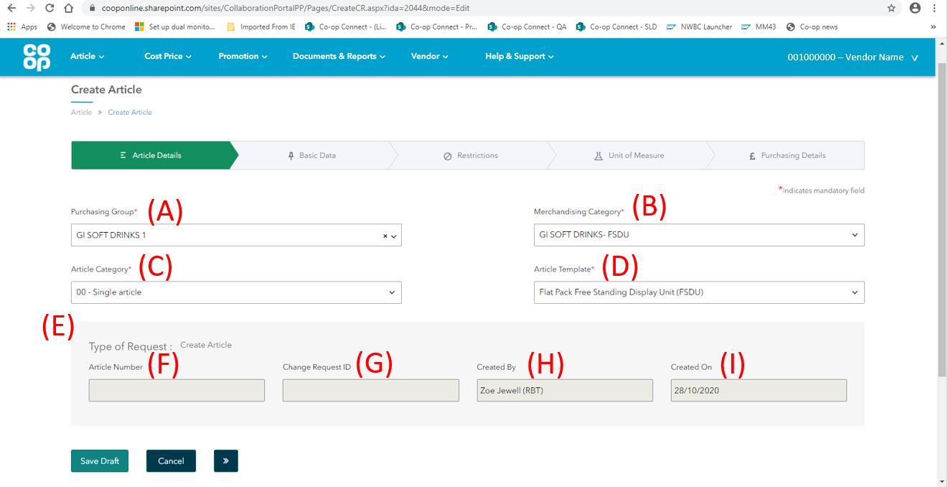
- Purchasing Group - The purchasing group links the article change request (CR) to the Buyer who is responsible for reviewing and approving the request in SAP. To find the correct Purchasing Group, you can either search for it by typing keywords in the search box or scrolling to find the correct option.

Please confirm with your buyer before selecting a purchasing group –
Once a purchasing group has been selected and the form has been submitted for approval, this field cannot be changed. Therefore, if the wrong purchasing group is chosen, the user will have to start the process of creating the article from the beginning.
Please see below for the full list of purchasing groups with the pre-fixes explained:

Purchasing Groups
BK = Bakery | FR REDUCED/PROMO | GS HERBS & SPICES | NF NEWSPAPERS
BK BREAD | FR SAVOURY PASTRY | GS HOME BAKING | NF PAYPOINT
BK CAKES | FR VEGETABLES | GS HOT BEVERAGES | NF PHONECARDS
BK CONCESSIONS | FTG = Food to go | GS INTERNATIONAL | NF POSTAGE STAMPS
BK DIRECT DELIVERY | FTG COFFEE | GS LONGLIFE MILK | NF POWER CARD
BK MORNING GOODS | FTG COFFEE SHOP | GS OPP BUY | NF REDUCED/PROMO
BK OPP BUY | FTG CONCESSION | GS PASTES & SPREAD | NF SAVING STAMPS
BWS = Beers, Wines and Spirits | FTG DELI BACON | GS PRESERVES | NF SEASONAL 1
BWS BEER 1 | FTG DELI CHEESE | GS SAUCES PICKLE O | NF SEASONAL 2
BWS BEER 2 | FTG DELI COOKED ME | GS SUGAR | NF STATIONERY
BWS SPIRITS | FTG DELI ETHNIC | HPC = Home and Personal Care | NF TABLEWARE/GIFTS
BWS WINE 1 | FTG DELI PATE | HPC BABY FOOD | NON TRADING EXCPTO
BWS WINE 2 | FTG HOT FOOD | HPC BABY TOILETRIE | PD = Produce
BWS WINE 3 | FTG ISB | HPC DENTAL | PD BANANA/EXOTIC
BWS WINE 4 | FTG PIES | HPC DEODORANTS | PD BERRIES/CITRUS
BWS WINE 5 | FTG QUICHE | HPC FOILS & WRAPS | PD CHILL PREPARED
CIGS = Cigarettes | FTG REDUCED/ PROMO | HPC HAIRCARE | PD GRAPE/STONE FRU
CIGS ACCESSORIES | FTG ROTISSERIE | HPC HOSIERY | PD HORTICULTURE
CIGS CIGARETTES | FTG SALADS | HPC HOUSEHOLD PAPE | PD ORGANICS
CIGS CIGARS | FTG SANDWICHES/SNA | HPC HOUSEHOLD PROD | PD POTATOES
CIGS TOBACCO | FTG STATIONERY | HPC MEDICINES | PD SALAD
DR = Dairy | FTG SWEET | HPC OPP BUY | PD TOP FRUIT
DR CHEESE | GI = Grocery Impulse | HPC PETFOOD | PD VEGETABLES
DR CREAM | GI BISCUITS | HPC SANPRO | PP = Provisions Prepared
DR CREAM CAKES | GI CONFECTIONERY 1 | HPC SKINCARE | PP PIES
DR DESSERTS | GI CONFECTIONERY 2 | HPC SUNPREPS | PP PIZZA
DR JUICE | GI CRISPS/SNACKS/N | HPC TOILETRIES MEN | PP PREPARED SALADS
DR MILK | GI OPP BUY | HPC TRANSFERS | PP READY MEALS
DR YELLOW/WHITE FA | GI SOFT DRINKS 1 | HPC WASHING/BATHIN | PT = Protein
DR YOGURTS/DESSERT | GI SOFT DRINKS 2 | NF = Non-food | PT BACON
ETHNIC | GS = Grocery Staples | NF CONCESSION | PT BEEF
FR = Frozen | GS AMB READY MEAL | NF ELECTRICAL | PT CHICKEN
FR CONFECTIONERY | GS BREAKFAST CEREA | NF ENTERTAINMENT | PT COOKED MEAT
FR FISH | GS CANNED FISH | NF FUEL | PT DIRECT DELIVERI
FR ICE CREAM | GS CANNED FRUIT | NF FURNITURE | PT EGGS
FR MEAT | GS CANNED MEAT | NF GARDENING/FUEL | PT FISH
FR MEAT FREE | GS CANS/DRY VEG | NF GIFT VOUCHERS | PT LAMB
FR MEAT PRODUCTS | GS CANS/PACKET SOU | NF HOME & LEISURE | PT PORK
FR PIZZAS | GS COOKING AIDS | NF HOMEWARES | PT READY TO COOK
FR POULTRY | GS DESSERTS/PUDDIN | NF LOTTERY | PT SAUSAGE
FR POULTRY PRODUCT | GS DRY SAUCES MIXE | NF MAGAZINES | PT SPECIALITY MEAT
FR READY MEALS | GS HEALTH FOODS | NF NEWS SPECIALS | PT TURKEY & DUCK

- Merchandising category - if an FSDU is being created, the merchandising category that is selected will need to have ‘FSDU’ included in the name, for example:
The options available in the dropdown menu will be specific to the vendor. If the merchandising category that the FSDU should belong to isn’t available in the dropdown list, please contact portal admin. Please see the next page for a full list of FSDU merchandising categories:

Merch Cat 5 Name
FINSBURY FSDU | TOYS FSDU | HOME&PSNAL CRE- FSDU
GI BISCUITS- FSDU | BWS- FSDU | GI CRISPS/SNACK-FSDU
SOREEN- FSDU | CIGARETTE-FSDU | TABLEWARE- FSDU
ETHNIC FSDU | NF MAGAZINES FSDU | CHINA/GLAS/GIFT-FSDU
NF HOME&LEISURE FSDU | GI CONFECTNRY - FSDU | ENTERTAINMENT FSDU
NF SEASONAL FSDU | GROCERY STAPLES FSDU | BAKERY -FSDU
GI SOFT DRINKS- FSDU

Please confirm with your buyer before selecting a merchandising category –
Once a merchandising category has been selected and the form is submitted for approval, this field cannot be changed. Therefore, if the wrong merchandising category is chosen the user will have to start the process of creating the article from the beginning.

- Article Category - The article category refers to the type of article being created. The following options will be available:

Article Category | Description
00 – Single Article | This will be the defaulted selection. Please select this option if creating anything other than a filled or partially filled free standing display unit.  For a flat packed FSDU, please select this option
12 – Display Article | Please select if creating a filled or partially filled free standing display unit (FSDU)

- Article Template – For a flat packed FSDU, the option that needs to be selected in the article template field is “Flat Packed Free-Standing Display Unit (FSDU)”, as shown below:
- Type of Request – Create Article – The ‘Type of request’ greyed out section will display 4 fields that are not for the Vendor to complete. The 4 fields will be:

- Article Number - This will be the FSDU’s unique ID number. This field will be empty initially, and will automatically populate once the FSDU has been approved and has hit our central SAP system.

- Change Request ID – Whenever a request is made via Co-op Connect to change our records (article details, cost price proposals etc), a Change Request number will be attached. For ‘Create Article’ requests, this change request ID will be visible in the ‘My Change Requests’ screen under the main ‘Article’ header. The ID of the change request will also be visible in the ‘Saved Successfully’ banners as you move through the form.
- Created By – The Created By field records which user created the Change Request. This will be the name of the user who originally created the CR.

- Created On – The Created On field records when the CR was first created.

2.2. Create Article - Basic Data
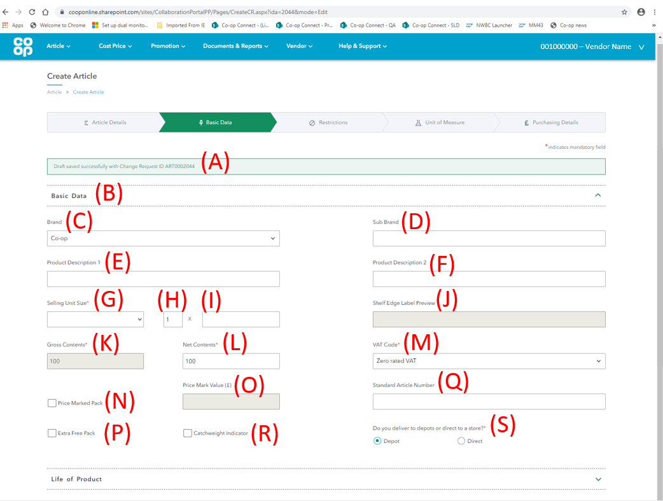
- Success Banner - A green success banner will appear at the top of the page indicating a draft Change Request (CR) has been created and saved with an ID (ART******). You will be able to find this draft CR in the ‘My Change Requests’ screen under the main Article Header.

- Basic data tab - This page is split in to 3 different sections. The first section is ‘Basic Data’ and will be readily open.

- Brand - According to GS1, the brand is the highest brand on the front of the pack where ‘highest’ refers to widest covered brand, not necessarily the highest positioned brand.

For an FSDU, the brand field will need to reflect the brand of the article that will be advertised on it in stores. The options available in the dropdown menu are specific to the Vendor.

- If the FSDU will have more than one brand advertised on it when in stores, please complete the ‘Brand’ field with the primary brand and use the ‘Sub Brand’ field for any others. Please see the next page for an example

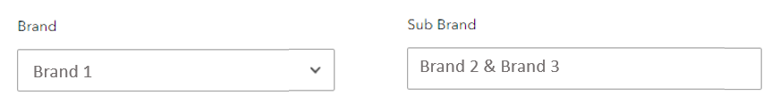

- Sub Brand – According to GS1, the Sub-brand refers to any brand on the packaging which is not the widest covered brand. If the article has an associated sub-brand, please complete the sub-brand field.

- Product Description 1 - Please complete Product Description 1 with the description of the FSDU, and include ‘FSDU’ for identification. This should not include any brand or sub brand information.
This field is capped at 40 characters.

- Product Description 2 - Product description 2 can be used for long descriptions which need more characters. This should not include any brand or sub brand information.
This field is also capped at 40 characters.

(G, H, I) Selling Unit Size fields –
For an FSDU, the selling unit size refers to the size of the FSDU as a whole. This is split in to 3 separate fields:

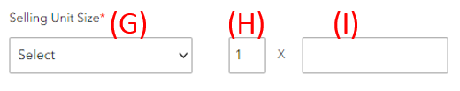

- Selling Unit size (Unit Dropdown) – The first field is for you to select the unit to which the FSDU is measured in. For a flat packed FSDU, please select one of the following:

Dropdown option | Full description | Example
EACH | Each | Each – FSDUs
UNIT | Unit | Unit – FSDUs

- Multipack Indicator - The second field is to indicate whether the article is a multipack item e.g. 4x330ml cans, 12x30G Crisps. For a flat packed FSDU, this value should always be ‘1’.

- Selling size - The three fields together capture the size of an individual selling unit, or in this case it will reflect the size of the flat packed FSDU. This value should always be ‘1’ for a flat packed FSDU, as shown below:
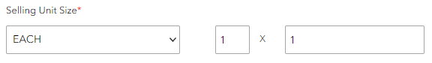

The shelf edge label should look similar to the below:

- Shelf edge label preview - The Shelf Edge Label Preview field has been created to help preview the total description of the article or FSDU. This includes the fields:
- Brand
- Sub-brand
- Product Description 1&2
- Selling Unit Size

There should be no duplication or misspelling of information in this field.

- Gross contents - The Gross Contents field is greyed out and is not to be completed by the user. This will automatically populate using the value inputted in the Selling Unit Size field.

- Net contents - The Net Contents will automatically populate using the value inputted in the Selling Unit Size field, like Gross Contents. Net contents can be altered by the user.

For a flat packed FSDU, the Net and Gross contents should auto complete to ‘1’ as shown below:
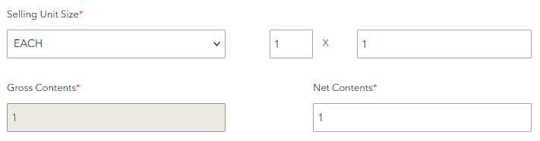

- VAT Code - Please select the right VAT code from the dropdown menu for the FSDU.

- Price Marked Pack – a price marked pack is an article which has a price marked on its packaging. This should not be ticked for a flat packed FSDU.

- Price Mark Value – A value should only be entered in to the price mark value field if the following criteria are met:
- The 'Price Marked Pack’ checkbox has been ticked
- The price that is marked on the packaging is permanent to the article number

A value should not be entered in the Price Mark Value field for a flat packed FSDU.

- Standard Article number – For an FSDU (flat packed or pre-filled), the standard article number field will need to be completed with the article number of the primary article that will be advertised on the FSDU.

Please enter the article number for the primary article in this field. Once the article number is typed, click off the field. If the article number is recognised, the article description will show under the field as shown below:

The standard article number field should be completed with an article number a flat packed FSDU.

- Catchweight indicator – This should not be ticked for a flat packed FSDU.

- Delivery method– Please indicate whether the FSDU will be delivered via the Co-op’s depot network or direct to Co-op’s stores by clicking one of the checkboxes (if both are applicable select ‘depot’).

2.3. Create Article – Life of Product

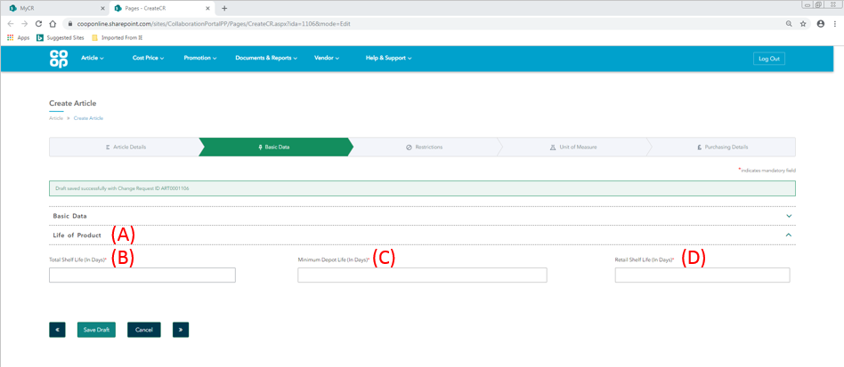

- Life of Product – this is the second tab that will be available within the Basic Data screen. This tab can be opened by clicking the down arrow on the right hand side

- Total Shelf Life in days – The total shelf life of an article is the amount of days from the date of production to the date of expiry
For flat packed FSDUs, please enter: 9999

- Minimum Guaranteed Shelf Life in days - This is the agreed minimum life in days that an article can have on receipt in to Depot if delivered via DC (distribution centre) or into store if direct to store. This is therefore the amount of days life the article will have from the day it is received by Co-op until its expiry date, excluding day of delivery.
For flat packed FSDUs, please enter: 9999

- Retail Shelf Life in days - This is the agreed minimum life in days the article has once delivered to store. Therefore, this is the number of days from the day it is delivered in to our stores until its expiry date, excluding day of delivery.
For flat packed FSDUs, please enter: 999

2.4. Create article – Restrictions

When creating a flat packed FSDU the Restrictions tab will be pre-completed. There are no actions for the Vendor to complete on this tab, please scroll to the bottom of the page and proceed to the Unit of Measure tab using the navigation buttons.

2.5. Create Article - Unit of Measure
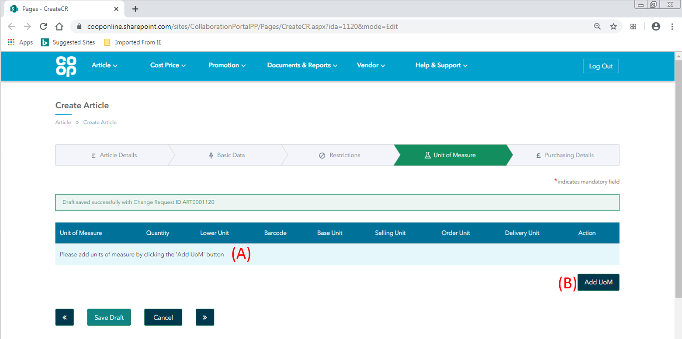

The unit of measure screen is where the user will create the units associated with the new FSDU, including the dimensions and barcodes. Once the units are created, they will populate table (A). The user will then categorise the units as the base, selling, order or store delivery units in the table.
- Unit of Measure Table – for the ‘Create Article’ process this table will be empty. When each unit associated with the FSDU is created, the table will populate with the unit information

- Add UoM – Please click the ‘Add UoM’ button to create the units of measure associated to the FSDU. See ‘1.7.2. Add unit of measure pop up’ section for next steps.

Reminder of Terms
- Base Unit = The Base unit is the equivalent of a SKU (Stock Keeping Unit). This will always be set against the Each UoM unless the article is sold by weight in-store, where the Base UoM will be set against the KG UoM.

- Selling Unit = The selling unit can be described as the individual unit that the Co-op will sell to a customer. Each selling unit equals one beep at the till (Selling unit has previously been known as a consumer unit)

- Order Unit = The order unit is the unit that the Co-op will order from their suppliers. E.g. Co-op wouldn’t order each individual chocolate bar, instead they would order a case of 36 chocolate bars, which would then each be sold as 36 individual selling units (Order Unit has previously been known as Traded Unit).

- Store Delivery Unit = The store delivery unit is the unit that will be delivered to Co-op stores (in most cases, this will be the same as the Order Unit). A store delivery unit differs from the Order Unit if the stock that the supplier sends in the depot is then split up when sent to stores. An example of this is cigarettes – Co-op will receive a case of Cigarettes that holds 10 individual sleeves of cigarettes which we will then send to stores.

Units of Measure (for an FSDU)=
- Each = This unit is used to represent a single selling unit that would be on the shelf in-store

- Layer = This unit is used to represent the number of Cases or Each’s that are present on one layer of a pallet

- Pallet = This unit is used to represent the number of layers that are present on one pallet

2.6.1. Examples of how the screen will look once the units have been created for a flat packed FSDU

- Each – Layer – Pallet (flat packed FSDU delivered to depot)

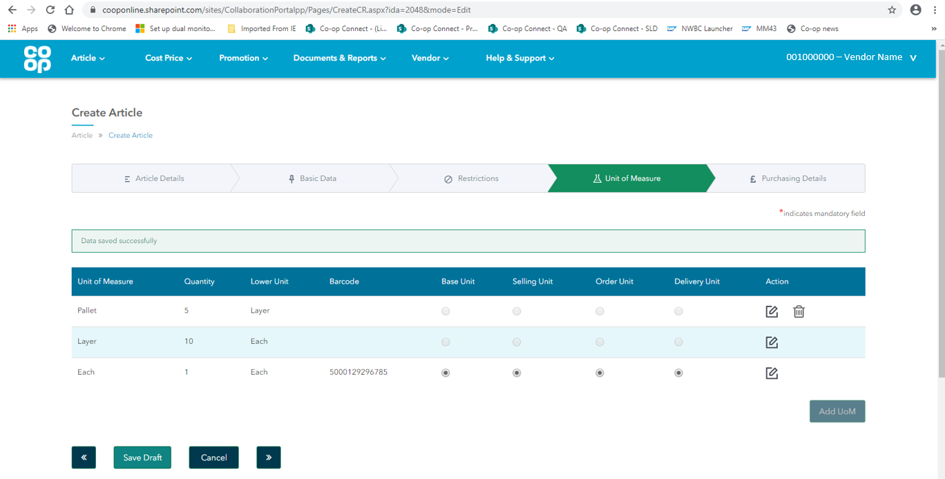

2. Each – Layer – Pallet (Flat packed FSDU delivered direct to store)

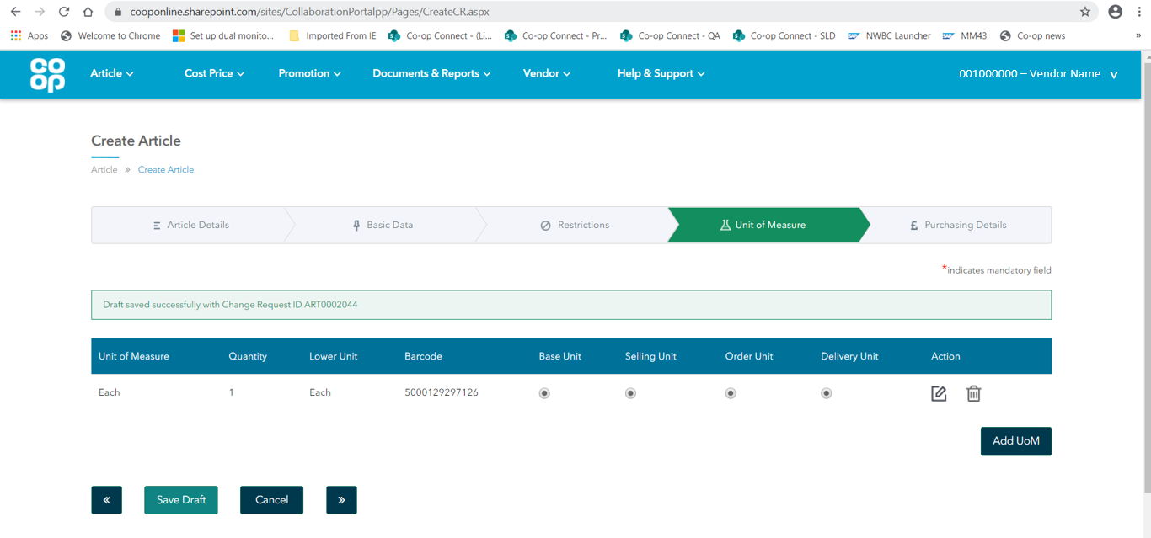

2.6.2. Add Unit of Measure Pop Up

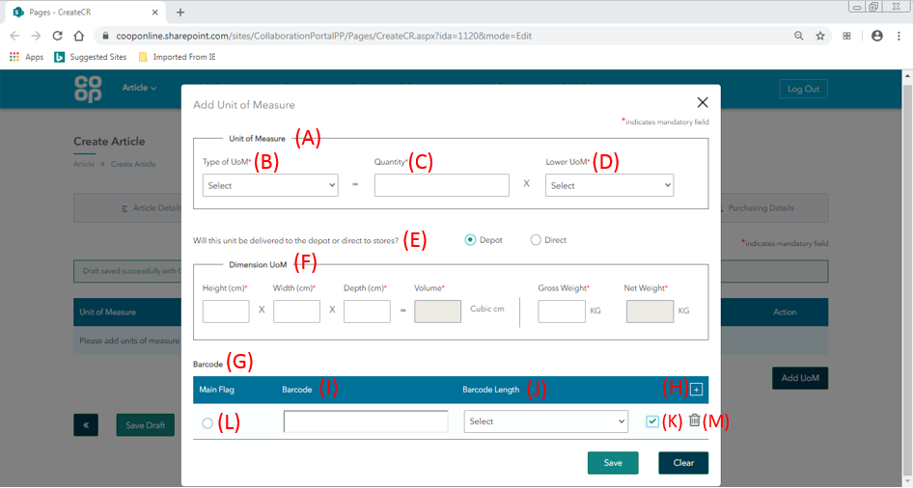

- Unit of Measure section – this section is made up of 3 fields, and aims to understand what unit is being created, and what makes up that unit (the quantity of lower units). For a flat packed FSDU, the only units that will need to be created are:

An ‘Each’ unit – the ‘each’ unit will be the FSDU:

A ‘Layer’ unit (if delivered to Depot). The example below shows the layer being made up of 10 FSDUs:

A ‘Pallet’ unit (if delivered to Depot). The example below shows the pallet being made up of 8 layers:

- Type of UoM – First, select the type of unit that is being created. The units must be created from the smallest upwards, in the order of Each Pallet. The options available in the dropdown will depend on the units that have already been created.

When creating the first unit for a flat packed FSDU, please select:
- Each – This unit is used to represent the FSDU

Other options that will be available once the first unit has been created will be:
- Sleeve
- Case
- Layer
- Pallet

- Quantity - The Quantity field is asking how many lower units make up the unit which is being added, please see examples above in section (A).
- Creating an Each –always ‘1’
- Creating a Layer – Enter either the quantity of FSDUs per layer
- Creating a Pallet – Enter the quantity of layers per pallet

- Lower UoM (lower unit of measure) – The unit in this field multiplied by the value in the quantity field should make up the unit being created, please see examples in (A).
Unit being added = Lower UoM x quantity

The lower UoM field will show a dropdown menu with the available lower units for the unit being created, which will depend on the units that have already been added.
- Creating an Each – Select each
- Creating a Layer – Select each
- Creating a Pallet – Select layer

- Will this unit be delivered to the depot or direct to stores? – Please select whether this unit will be delivered to the depot or to the store. This will automatically default to the same as the answer from (S) in section 1.2. Create Article – Basic Data.

- UoM Dimensions – these fields will only be available when creating the ‘each’. Please enter the shipped dimensions of the FSDU (Co-op need these values to understand how we will receive the FSDU)
- Height, Width and Length are all in centimetres
- Volume is in Cubic Centimetres, and is auto-calculated (not entered by user)
- Gross and Net weight are in KG
- The Net weight is auto-calculated (not entered by user)

GS1 Global standards – determining product measurements
If adding the dimensions of a flat packed FSDU:
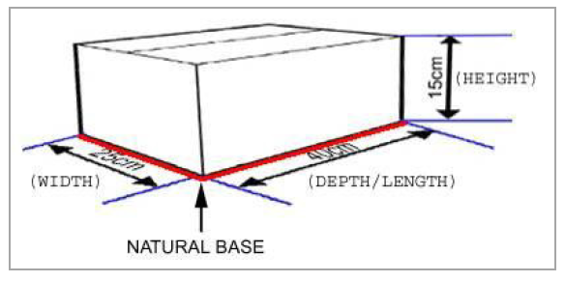
- According to GS1, each non-consumer trade item will have a natural base when being shipped. Once the natural base has been identified, use the following guidelines to determine the Width, Depth and Height of the flat packed FSDU
- Identify the natural base of the unit
- The height is measured from the natural base to the highest point of the unit
- The depth is the longer of the remaining sides that form part of the natural base
- The width is the shorter of the remaining sides that form part of the natural base
- The Volume field automatically populates and is calculated by multiplying the Height, Width and Depth fields together.

- Barcode – This table is where the barcode information for the flat packed FSDU will be added. The barcode that is either entered (for branded FSDUs) or requested (for Co-op branded FSDUs) for the ‘Each’ should be the barcode of the actual FSDU. This will be the barcode that the Co-op use to order the FSDU.

It’s split in to 4 different parts:

- ‘+’ – click this button to open up the barcode table

If creating a Co-op branded FSDU:
The screen will now look like the below. For Co-op branded FSDUs, the Co-op will provide a barcode. Please follow the steps below to request a barcode for each of the units -

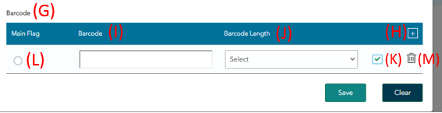
- Barcode field – Please leave this blank
- Barcode Length – Please select from the dropdown menu the length/ type of barcode needed for the unit. If unsure, please contact your buyer.
- Tick/ Check button – Once the barcode length field is selected, please click the ‘Check’ button. This will populate the ‘Barcode’ field with the requested barcode from Co-op.
- Main Flag – Tick the main flag radio button to let Co-op know this will be the main barcode for this unit
- Bin/ Delete – if a mistake has been made, please use the Bin icon to delete the line from the barcode table

If creating a branded FSDU:
The screen will now look like the below. For FSDUs that are not Co-op branded (including non-branded) the Vendor should provide the barcode. Please follow the steps below to provide a barcode for each of the units -
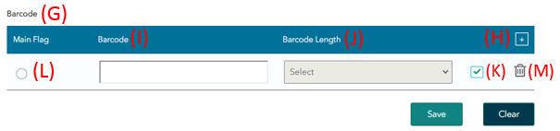
- Barcode field – Please enter the barcode of the flat packed FSDU

- Barcode length – this field will be greyed out, please leave blank

- Tick/ Check button – Once the barcode field has been completed, please click the ‘Check’ button. Once the barcode is verified in Co-op’s system, both the ‘barcode’ and ‘barcode length’ field will grey out

- Main Flag – Tick the main flag radio button to let Co-op know this will be the main barcode for this unit

- Bin/ Delete – if a mistake has been made, please use the Bin icon to delete the line from the barcode table
Once all the steps have been completed, click the ‘Save’ button to save the unit to the Unit of Measure table. Please see below for an example after an Each has been created and added to the table:

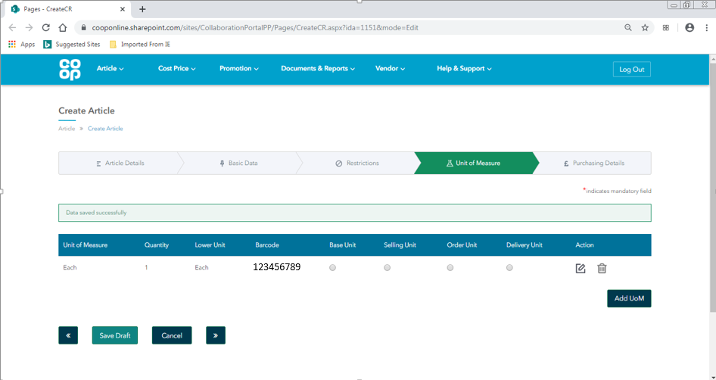

Repeat the steps in section 1.7. Create Article – Unit of Measure until all units associated with the FSDU have been created and added to the Unit of Measure table. Examples of how this should look are included in the 1.7.2. Add Unit of Measure Pop Up section.

2.6.3. Unit of Measure – finished example

Each – Layer – Pallet (Delivered to depot)

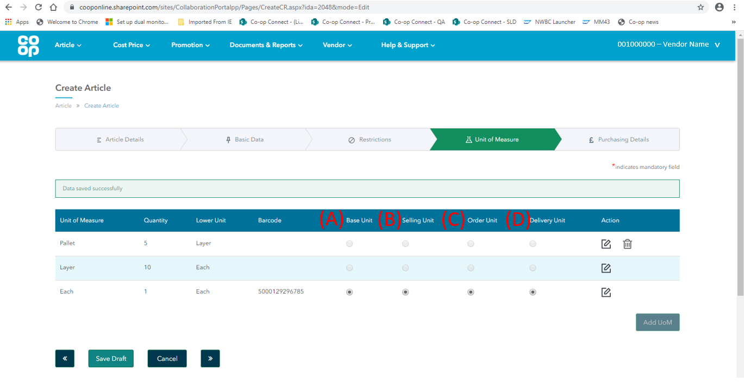

Once all the units that are associated with the FSDU being created have been added to the table, the next step is to categorise each of these units:

- Base unit
- Selling unit
- Order unit
- Store Delivery Unit

Please tick the Base, Selling, Order and Delivery unit radio buttons for the FSDU. The table below shows each of the units of measure, and which unit categories they can be recognised as:

Unit of Measure | Possible unit categories
Each | Base, Selling, Order, Store Delivery
Layer | N/A
Pallet | N/A

- Next button – once all the units have been added and categorised, please click the ‘>>’ navigation button to proceed to the last tab

2.7. Create Article – Purchasing Details
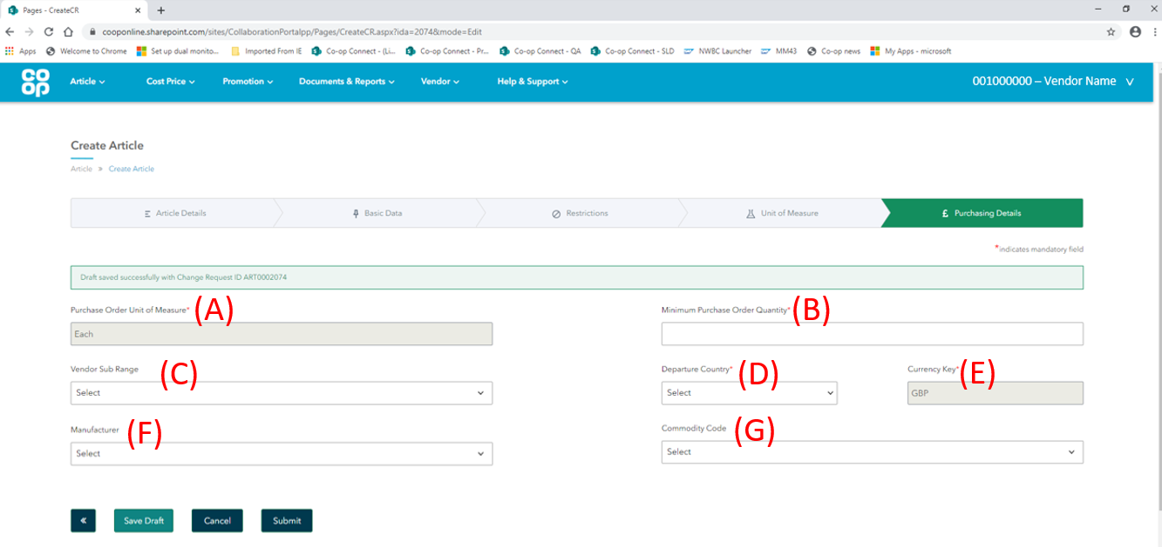

- Purchase Order Unit of Measure – this will show unit of measure that was selected as the order unit in the previous page. For a flat packed FSDU, this should always show ‘Each’.

- Minimum Purchase Order Quantity – Minimum Purchase order quantity is the smallest multiple of units that the Co-op can order.

- Vendor Sub Range – if available, this will be a dropdown menu of sub ranges specific to the vendor. Please select the relevant option for the article being created.

- Departure Country – the departure country is the country the article will be sent from. Please select the country the dropdown menu.

- Currency Key – the currency key field will display the currency in which the FSDU will be purchased by the Co-op. This will auto populate from the information that Co-op holds on the Vendor (or sub range if selected). This will be greyed out.

- Manufacturer – Please select the manufacturer of the article being created. This is a Vendor specific list, and will display all options associated with your Vendor account. If another manufacturer is needed, please contact portal admin.

- Commodity Code – If the article has been imported, the commodity needs to be selected. This is a 10 digit number that is allocated to articles to classify imports from outside the European Union.

This field only needs to be completed if the article has been directly imported, we only request a commodity code to be selected if the article has been sent from outside the UK. If the article has been imported to a supplier depot and then sent in to Co-op, we do not require a commodity code to be selected.

For more information, please see the following link:
https://www.trade-tariff.service.gov.uk/sections
Once all the information is complete, please click submit. This will send the Create Article Change Request for the flat packed FSDU to your buyer.

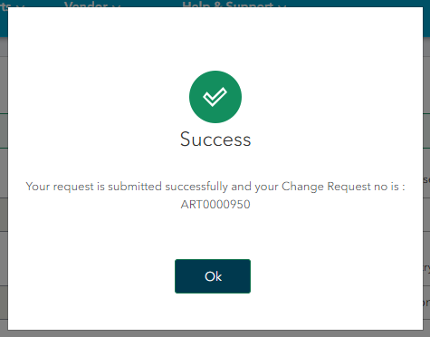

A success popup window will appear with the Change Request number for the Create article CR - this will be in the format of: ART******. This CR number is a unique identifier for the change request and will be shown in the ‘My Change requests’ screen in Co-op Connect, and to the Buyer in the Co-op system.

Pressing ‘OK’ will direct you back to the homepage. To view an article submission, click the ‘My change requests’ option in the ‘Article’ main header.

3.0. View Create article change request

Key points/ Top tips

- An article CR can be viewed in the ‘My change requests’ screen under the ‘Article’ header

- The change request number for an Article CR (including FSDUs) will begin with the letters ‘ART’

- The NSL and barcodes can be found by opening the extract of the change request. The codes will be populated on the 2nd and 3rd tabs

3.1. Homepage
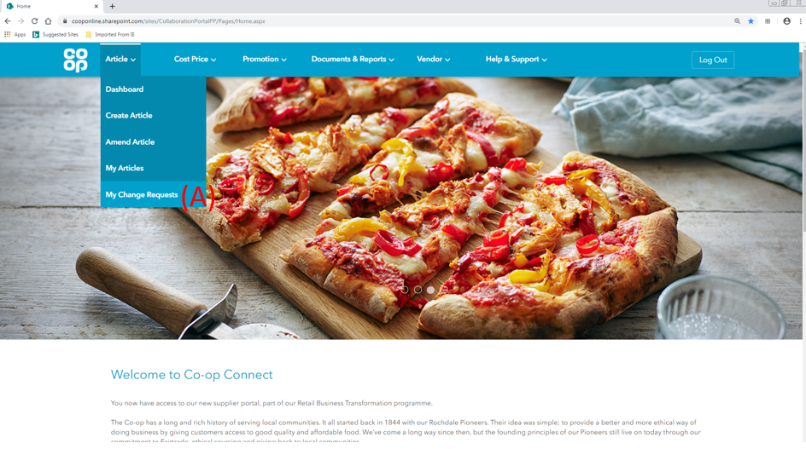
- Click on the ‘My Change requests’ option from the ‘Article’ menu in the main header

3.2. My Change Requests
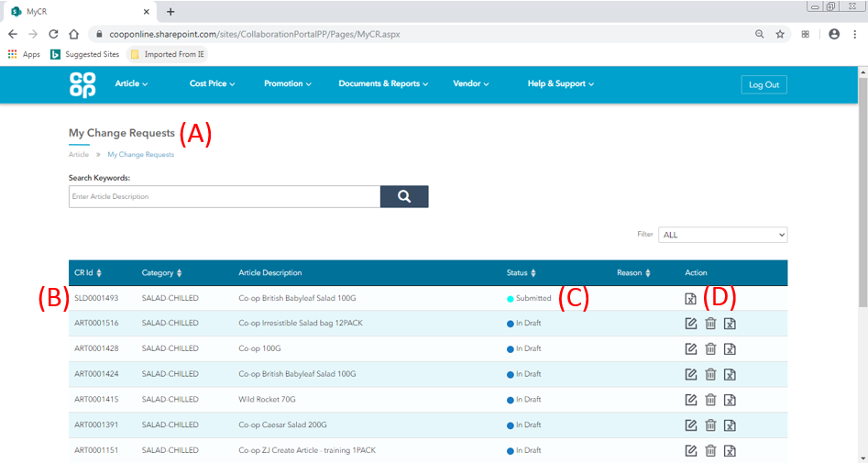
- My Change Requests – this screen will display all of the change requests for the following processes:
- Create Article
- Amend Article
- Shelf Life derogations

- CR Number – the change request number for create and amend change requests will begin with the letters ‘ART’. Find the create article CR in the table.

- Status – This column shows the status of the change requests. Please see below for a full list of statuses with their descriptions:
Status | Description
Draft | The article CR has been started and saved, but not yet submitted. The buyer will only see the article CR once submitted.
Submitted | The article CR has been submitted, and has not yet hit Co-op’s systems. This status should only show for a short period of time.
In Progress | The article CR has successfully hit our system, and is now with the buyer for review.
Sent back for revision | The article CR has been sent back for review by the buyer. Please make the agreed amends to the proposal and resubmit to the buyer for a second review.
Approved | The article CR has been approved by the buyer
Rejected | The article CR has been rejected by the buyer
- Actions – the action icons available for each change request will depend on the status the change request is in. A list of all icons are below:
Icon | Description | Available for change requests:
 | Bin Icon - Delete a change request proposal | In draft status only
 | Amend – amend the details of a change request | In draft status only
 | Extract – View the change request by exporting the information in to an excel document | In all statuses
 | Buyer notes – comments from the buyer on review | That have been in ‘sent for revision’ or ‘rejected’ status

Click on the extract icon to view a change request

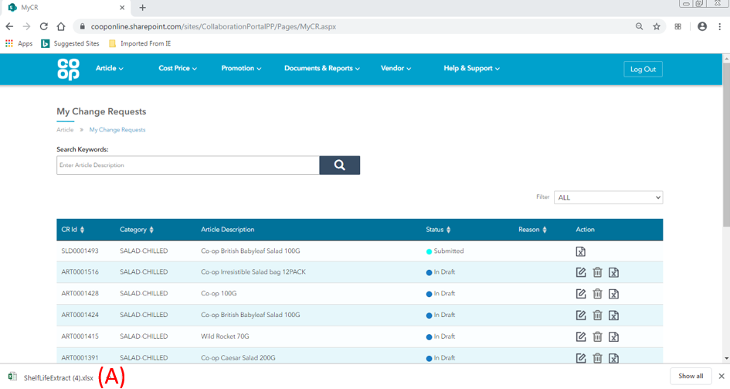
For Google Chrome users

- Excel download – once the print extract icon has been clicked, an excel version of the information will be downloaded on to the users computer. Click on this download to open the document in an excel file. This document can then be saved if required.

3.3. Extracted Form
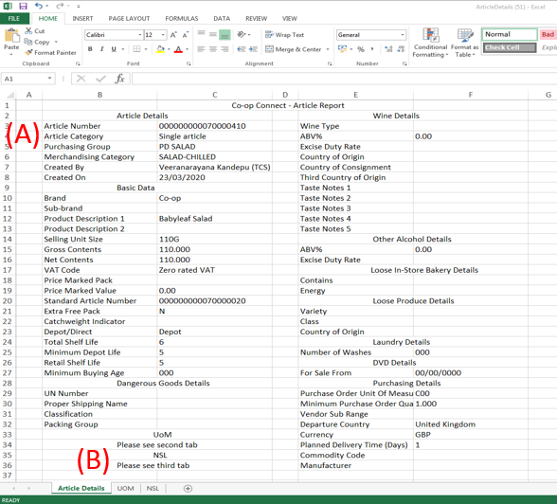
Once the downloaded file has been opened, the article information will be displayed in an excel format
- Article Details tab – for create article CR’s, the information displayed will be the information that has been added by the Vendor for the CR.

The extract will show all of the fields in Co-op Connect. Some of the fields will be empty as they will not have been required for the type of article. E.g. Taste notes will be empty for a bakery article.

- Tabs – 3 tabs will be available:
- Article Details – will show the majority of the details entered by the Vendor
- UOM – the details from the Unit of Measure screen
- NSL – the details from the Barcode linking screen

