Co-op Connect Training
View / Amend Vendor Details
View and amend vendor details, and view vendor details change requests
Contents
1.0. View / amend Vendor Details 3
Key points/ Top tips 3
1.1. Homepage 4
1.2. View/Amend Vendor Details 4
1.3. View/ Amend Vendor Details - General Details 5
1.4. View/Amend Vendor Details – EDI Details 6
1.4.1. View/Amend Vendor Details - Define New Forwarder 7
1.5. View/Amend Vendor details – Address 8
1.6. Bank Details 9
1.6.1. Add Bank Details Pop up 10
1.6.2. Upload Documents 12
1.7. Purchasing Details 13
1.7.1. Add Purchasing details pop up 13
2.0. View Vendor change requests 15
Key points/ Top tips 15
2.1. Homepage 15
2.2. My Vendor Changes 16
2.3. View Vendor Details change request 17

Co-op Connect Training - View/ Amend Vendor Details
This training guide will show the details of:
- Viewing Vendor details
- Amending Vendor details
- Viewing Vendor change requests

1.0. View / amend Vendor Details

Key points/ Top tips

- Once on the view/amend details screen, sections of information that the Co-op holds for the Vendor will be displayed in each of the greyed-out fields.

- To amend the details, tick the ‘Edit’ checkbox in the top right corner of each section. This will enable the fields that Co-op allows to be edited by the Vendor. Complete the fields that need new information and submit the form for Co-op to review.

- If a section has been edited, and the change is no longer required, unchecking the ‘edit’ button of the section will revert the details to their original values.

- If the information that you wish to edit remains greyed out then please contact the Portal admin team at the Co-op for further advice.

- If EDI details need to be amended, please give as much notice as possible by submitting an Amend Vendor change request at the earliest convenience.

1.1. Homepage
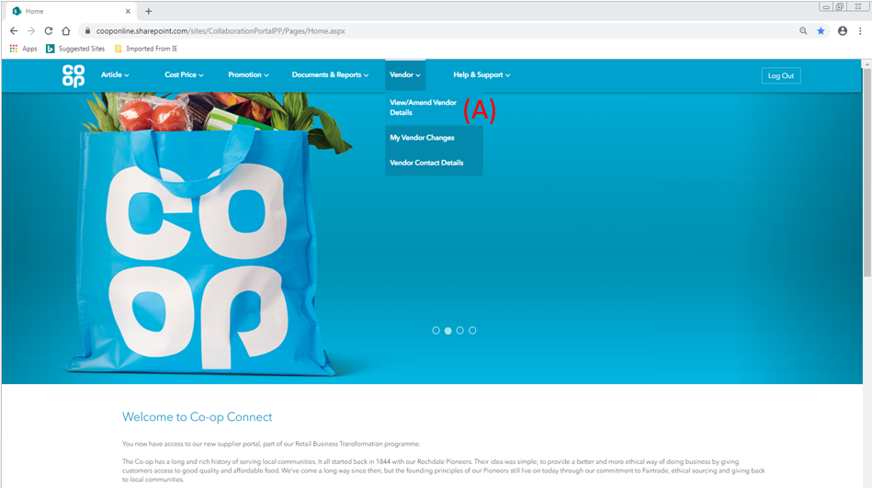
- To view or amend Vendor details, please hover over the ‘Vendor’ option in the main header and click on ‘View/Amend Vendor Details’

1.2. View/Amend Vendor Details
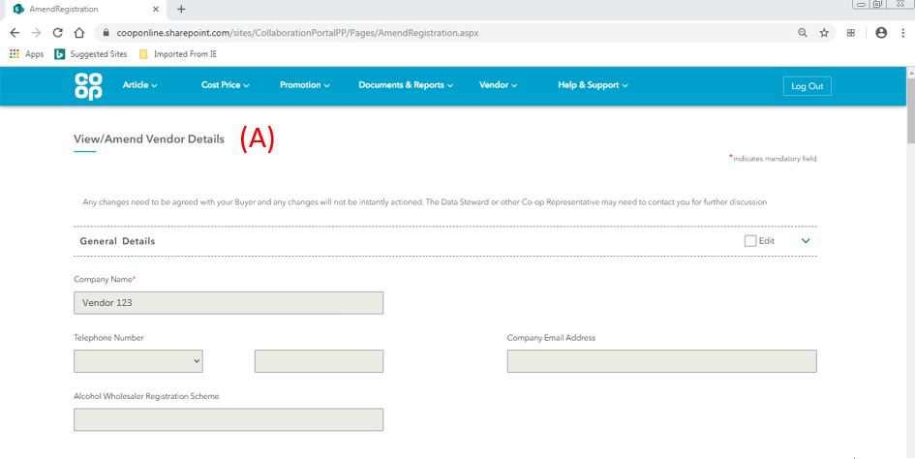
- View/ Amend Vendor details – the form is split in to 5 different sections:
- General Details
- EDI Details
- Address
- Bank Details
- Purchasing Details

1.3. View/ Amend Vendor Details - General Details
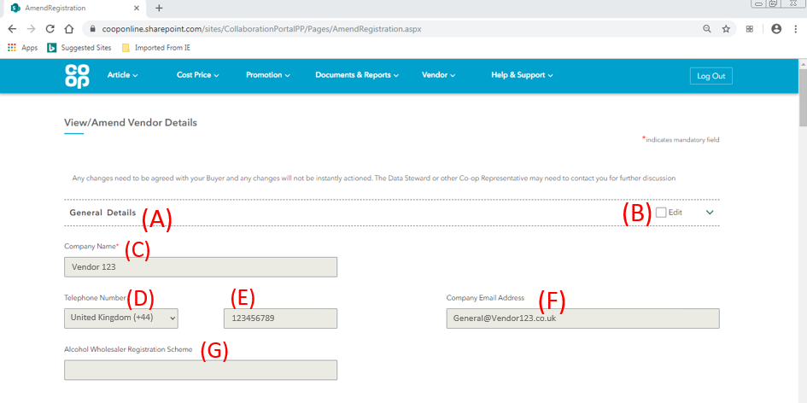

- General Details tab - the information that we currently hold for your Vendor will be populated in each of the fields.

- Edit – If you wish to edit the information within the ‘General Details’ tab, please tick the ‘Edit’ checkbox. The fields will then turn white and will be available to amend.

If a section has been edited and the change is no longer required, unchecking the ‘edit’ button of the section will revert the details to their original values.

- Company Name – The Company Name field should be the registered Company name of the Vendor.

If amends are made to the Company Name field, the Vendor will be required to upload a Company Registration document as part of the Vendor details change request. Please see section 1.6.2. Upload documents.

- Telephone number (Country code) – the country code of the general telephone number of the Vendor

- Telephone number – the general telephone number for the Vendor.

- Company Email Address – a main and generic email address for the Vendor

- Alcohol Wholesaler Registration Scheme (For alcohol Suppliers only) – the Vendors AWRS code, which should consist of 4 letters and 11 numbers. Example format: XXAW 000 0012 3456
For more guidance, please visit the link:
https://www.gov.uk/guidance/the-alcohol-wholesaler-registration-scheme-awrs

1.4. View/Amend Vendor Details – EDI Details
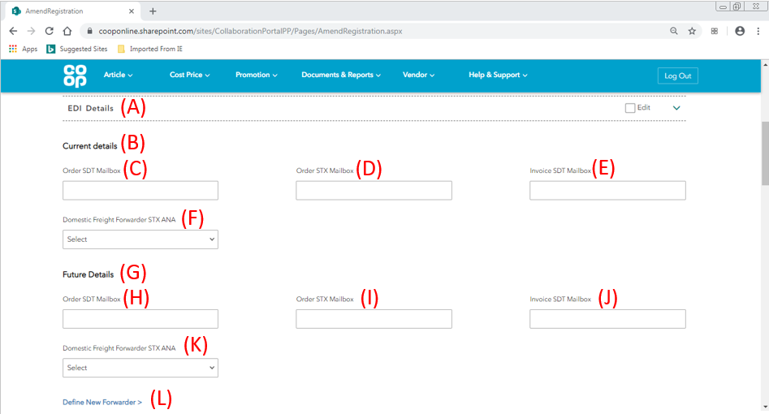

- EDI Details tab - All of the fields in the EDI Details tab will be empty. These fields should only be used for amending the current information that Co-op holds for the Vendor. To amend this information:

- Click the ‘Edit’ checkbox in the top right hand corner
- Complete the ‘Current details’ fields with the information that Co-op currently holds for your Vendor.
- Complete the ‘Future details’ fields with the information that you wish to change to

- Current details – the fields for the ‘Current details’ will be empty and greyed out. If the Vendor EDI details need amending, please tick the ‘Edit’ box and enter the current EDI details that the Co-op holds for your Vendor in the ‘Current Details’ fields:

- Current Order SDT Mailbox – the 13 digit number for the mailbox that the Co-op are currently sending orders to

- Current Order STX Mailbox – the 13 digit number that is the current identifier for the Vendor. The Order SDT and STX can be the same number

- Current Invoice SDT Mailbox – the 13 digit number that is the current identifier for the invoicing element of the Vendor. This can be the same as the Order SDT if it is all done within the same business.

- Current Domestic Freight Forwarder STX ANA – the STX ANA of the forwarding mailbox for the Vendors domestic freight forwarder (if a domestic freight forwarder is used).

- Future Details – Please complete the Future details fields with the new information you wish to change to:

- Future Order SDT Mailbox - the 13 digit number for the mailbox that Co-op will send future orders to

- Future Order STX Mailbox - the 13 digit number that will be the new identifier for the Vendor. The Order SDT and STX can be the same number

- Future Invoice SDT Mailbox - – the 13 digit number that will be the new identifier for the invoicing element of the Vendor. This can be the same as the Order SDT if it is all done within the same business.

- Future Domestic Freight forwarder STX ANA - the STX ANA of the new forwarding mailbox for the Vendors domestic freight forwarder (if a domestic freight forwarder is used). If the code you are looking for is not in this dropdown, please used (K) Define new forwarder to provide the details of the Vendors new domestic freight forwarder.

- Define new Forwarder – this option is only to be used if the STX ANA details of the new domestic freight forwarder cannot be found in the dropdown list in (J).

Once clicked, more fields will appear on the screen. Please see section below

1.4.1. View/Amend Vendor Details - Define New Forwarder
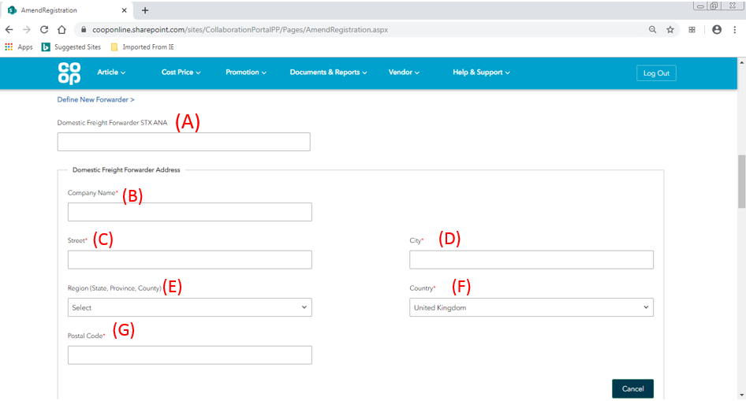
If the ‘Define New Forwarder’ link has been clicked, the following fields will appear as shown in the screenshot above.
- Domestic Freight forwarder STX ANA – Please provide the 13 digit mailbox code for the new domestic freight forwarder.
Domestic Freight Forwarder Address Outline – Please provide the company details of the new domestic freight forwarder by completing the following fields:
- Company Name
- Street
- City
- Region (State, Province, Country) - This list is dependent on the Country selected in the ‘Country’ field
- Country
- Postal code

1.5. View/Amend Vendor details – Address
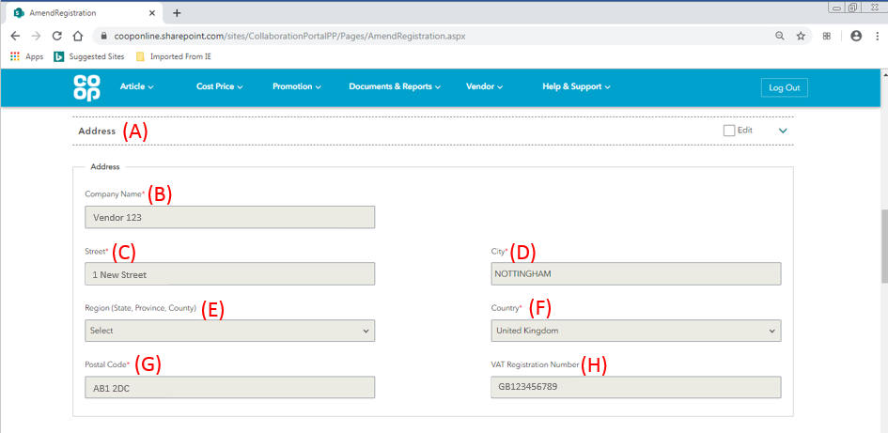
- Address tab – If you wish to edit the information within the ‘Address’ tab, please tick the ‘Edit’ box. The fields will then turn white and will be available to amend. If a section has been edited and the change is no longer required, unchecking the ‘edit’ button of the section will revert the details to their original values.

The address section will show the Head Office Address details for the Vendor in the following fields:

- Company name – This will automatically populate from the ‘Company Name’ field. To amend the Company name, please use the general details section.
- Street
- City
- Region (State, Province, Country) - This list is dependent on the Country selected in the ‘Country’ field
- Country
- Postal Code
- VAT Registration Number (required for UK Suppliers only) – the VAT Registration Number with the unique code provided to you by HMRC. This field is not available to amend. To amend this, please contact portal admin.

1.6. Bank Details
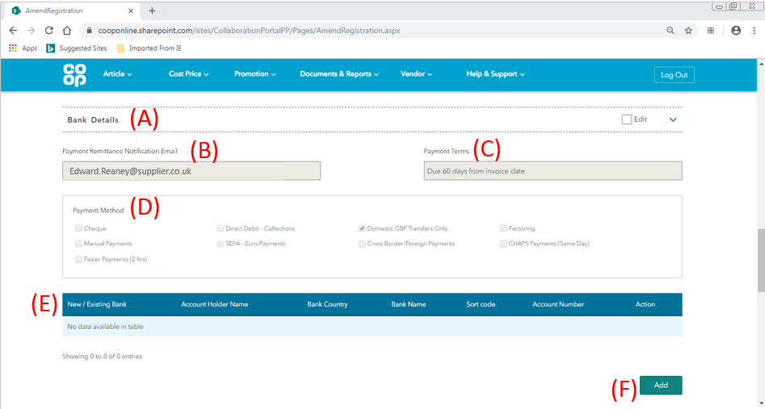
- Bank Details tab - If you wish to edit the information within the ‘Bank Details’ tab, please tick the ‘Edit’ box. The fields will then turn white and will be available to amend. If a section has been edited and the change is no longer required, unchecking the ‘edit’ button of the section will revert the details to their original values.

If amends are made to the bank details section, the Vendor will be required to upload several related documents as part of the Vendor details change request. Please see section 1.6.2. Upload documents.

- Payment remittance Notification email – The email address to which a notification will be sent once an invoice is paid by Co-op.

- Payment Terms – The agreed payment terms between the Vendor and the Co-op. This field is not available to amend. To amend this, please contact portal admin.

- Payment Method – The agreed method for how the Co-op will pay the Vendor. Multiple payment methods can be selected.

Payment Methods
Cheque
Direct Debit – Collections
Domestic GBP transfers Only
Factoring
Manual Payments
SEPA – euro Payments
Cross border/ foreign payments
CHAPS Payments (same day)
Faster Payments (2 Hours)

- New/Exiting Bank details table – The table will be empty. This table should only be used if you wish to amend the bank details that Co-op holds for the Vendor. To amend this information:

- Click the ‘Add’ button
- Complete the ‘Add Bank Details’ pop up with the existing the bank information that Co-op currently holds for your Vendor.

- Click ‘Add’ for a second time and complete the ‘Add Bank Details’ pop up with the new bank information that you wish to change to

- Add – if the bank details of the vendor need to be amended, click on the ‘Add’ button to populate the table with existing and future bank details. This button will only be available if the ‘Edit’ checkbox has been ticked on the Bank details section.

1.6.1. Add Bank Details Pop up
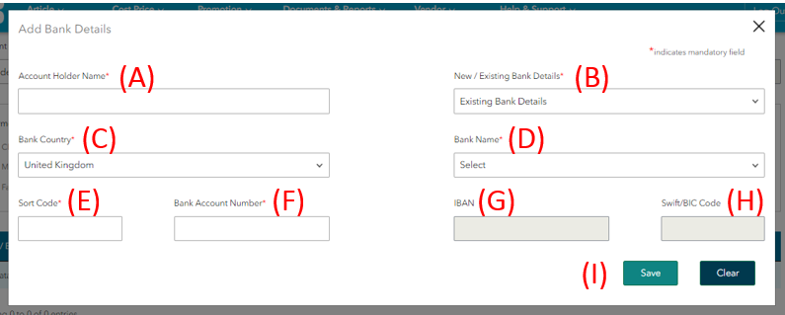

- Account holder name - Please provide the Account Holder name

- New/Existing Bank details – Please select whether the details being provided are the existing or the new bank details of the Vendor.

- Bank country – Please select the country of the Bank

- Bank Name - Please provide the Bank name by either:

- For Banks in the United Kingdom - Select the Bank Name from the dropdown list
- For Banks outside of the United Kingdom – Type in the Bank name

For Banks in the United Kingdom, complete the Sort code and Account number

- Sort code – for Banks in the United Kingdom, please provide the Sort code of the Bank Account for payments from Co-op. This will be a 6 digit number.

- Bank Account Number – for Banks in the United Kingdom, please provide the Bank Account Number of the Bank Account for payments from Co-op. This will be a 8 digit number.

For Banks outside of the United Kingdom, complete the IBAN and Swift/BIC code

- IBAN - (International Bank Account Number) – Please provide the IBAN of the Bank if it is outside of the United Kingdom.

- Swift/ BIC Code (Bank Identifier Code) - Please provide the Swift Code/ BIC for the Bank if it is outside of the United Kingdom

- Save - Once all of the details have been completed on the pop up, please click the ‘Save’ button to allow the information to populate the table on the main screen.

Repeat steps (A) – (F) to include both the Existing and New bank information for the Vendor. Please see below for an example of how a completed Bank Details table should look if the Vendor wishes to amend the existing bank details.
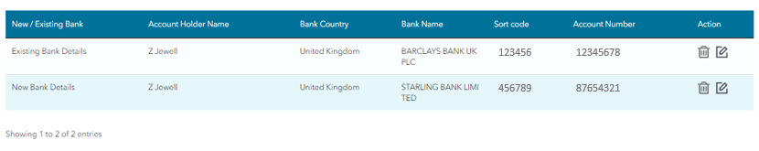

1.6.2. Upload Documents
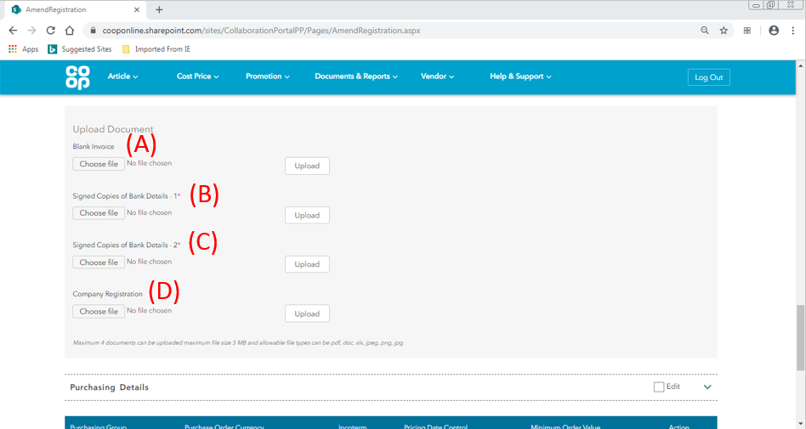

The following documents only need to be provided if amendments have been made. Please see below:
- If Company Name has been edited – Please provide the company registration document for proof of the change

- If Bank details have been edited – please provide a blank invoice, and 2 signed copies of the bank details.

For each of the four files, click on the ‘Choose file’ button and select the required document from your system. Once selected, click on the ‘Upload’ button to submit the file to the form. Please be aware that a maximum 5 documents can be uploaded, with a maximum file size of 5 MB. File types can be pdf, doc, xlx, jpeg, png, jpg

Please provide the documents if the following criteria is met:
- Blank Invoice – If bank details have been amended
- Signed Copies of Bank Details-1 - If bank details have been amended
- Signed Copies of Bank Details-2 - If bank details have been amended
- Company Registration – If company Name has been amended

1.7. Purchasing Details
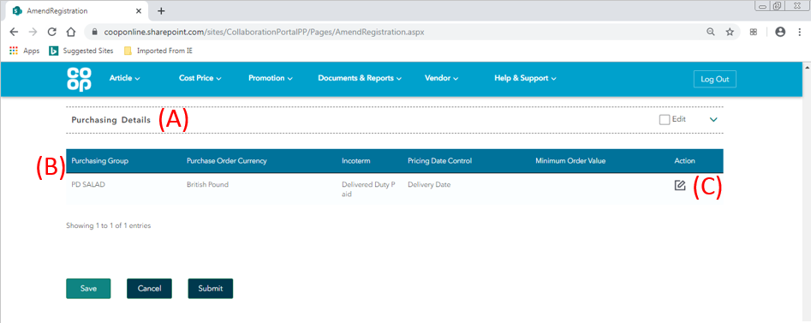
- Purchasing Details tab – If you wish to edit the information within the ‘Purchasing Details’ tab, please tick the ‘Edit’ box. The fields will then turn white and will be available to amend. If a section has been edited and the change is no longer required, unchecking the ‘edit’ button of the section will revert the details to their original values.

- Purchasing details table – the table will be populated with the current purchasing details information that Co-op holds for the Vendor.

- Edit – to amend the details, click on the notepad icon

1.7.1. Add Purchasing details pop up
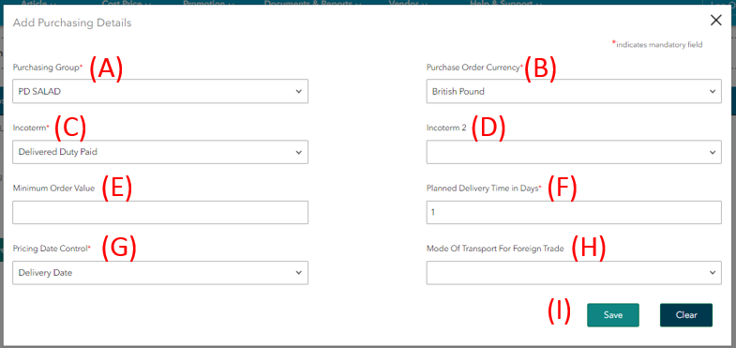
- Purchasing Group - The purchasing group connects the Vendor account to the associated buyer.

- Purchasing Order Currency – The currency in which the Co-op orders from the Vendor.

- Incoterm (international commercial terms) – The agreed commercial terms between the Vendor and the Co-op

- Incoterm 2 (if applicable) – If an article is imported, Incoterms 2 is the Country or the port that the article will be dispatched from

- Minimum Order Value (if applicable) – the minimum monetary value of any order placed by the Co-op across all articles from the Vendor.

- Planned Delivery Time in Days - The amount of days it takes between the Co-op ordering an article and then receiving it in to depot or store, excluding date of delivery

- Pricing Date control – This determines whether the price that the Co-op pays for an order is based on:
- the price of the articles on the date of order
- the price of the articles on the date of delivery

- Mode of Transport for Foreign trade (if applicable) – If you are importing goods from outside the United Kingdom, this defines the method of delivery

- Save – once all the applicable fields have been completed, click on save. If amends have been made, the table on the main screen will update.

If amends have been made, complete all the edits and click submit.
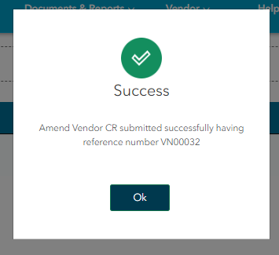
A success popup window will appear with the Change Request number for the Vendor Details change request - this will be in the format of: VN******. This CR number is a unique identifier for the change request and will be shown in the ‘My Vendor changes’ screen in Co-op Connect.

Pressing ‘OK’ will direct you to the ‘My Vendor changes’ screen. To view a Vendor details change request click the ‘My Vendor changes’ option in the ‘Vendor’ main header.

2.0. View Vendor change requests

Key points/ Top tips

- To view a Vendor detail change request, click on the CR number in the ‘My Vendor Changes’ screen

- Vendor detail change requests follow the format of ‘VN*****’

2.1. Homepage
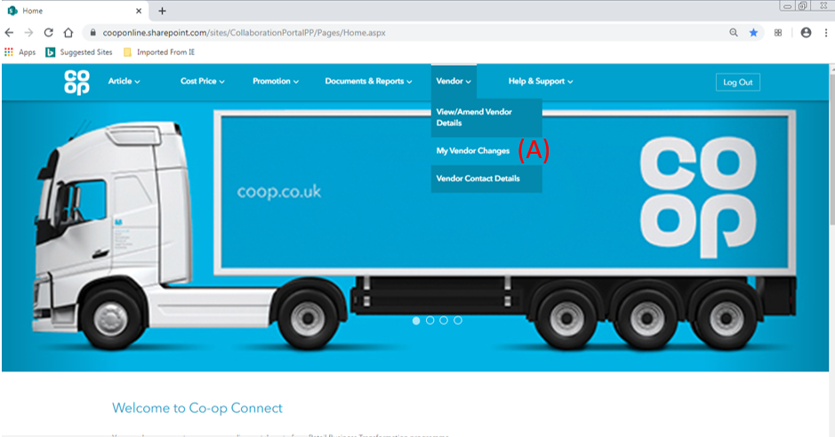
- Click on the ‘My Vendor changes’ option from the ‘Vendor’ menu in the main header

2.2. My Vendor Changes
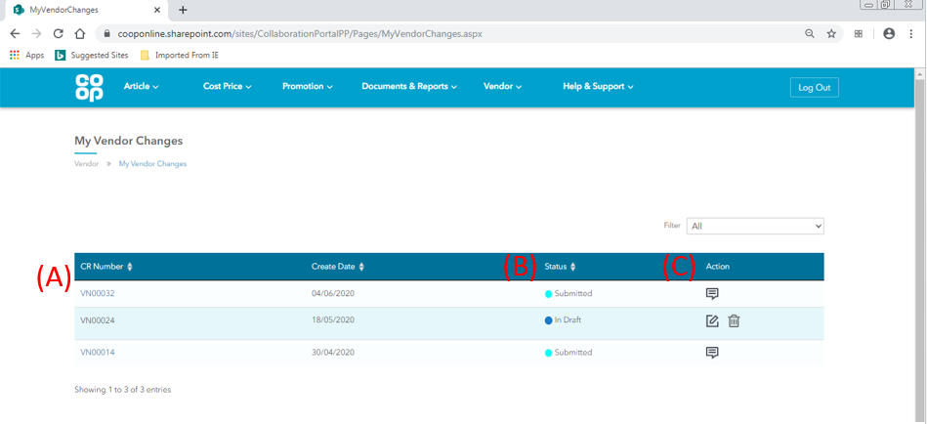
This screen will show all of the Vendor detail change requests for the Vendor.
- CR Number - the change request number for Vendor detail requests will begin with the letters ‘VN’. Click on the CR number of a Vendor detail CR to view.

- Status – This column shows the status of the change requests. Please see below for a full list of statuses with their descriptions:
Status | Description
In Draft | The Vendor details CR has been started and saved, but not yet submitted. This will only be seen by the Co-op for review once submitted.
Submitted | The Vendor details CR has been submitted, and an email has been triggered for a member of the Co-op to review
Approved | The Vendor details CR has been approved
Rejected | The Vendor details CR has been rejected

- Action - the action icons available for each change request will depend on the status the change request is in. A list of all icons are below:
Icon | Description | Available for change requests:
 | Bin Icon - Delete a change request proposal | In draft status only
 | Amend – amend the details of a change request | In draft status only
 | Co-op notes – comments from the Co-op on review | All statuses other than ‘In Draft’

Click on the CR number to view a change request

2.3. View Vendor Details change request
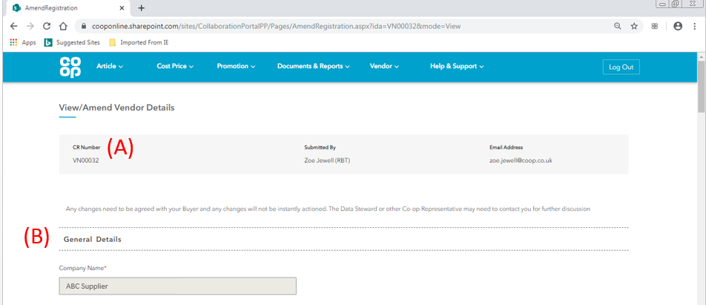
- CR Details – the change request number and the details of the user who submitted the change request will be displayed at the top of the screen.

- Change request details – the details of the Vendor change request will be detailed in the tabs below.

- For information that has not been edited – the change request will show the information that the Co-op currently holds for the Vendor.

- For information that has been edited – the change request will show the proposed new values and information from the Vendor.

Any section that has had the Edit checkbox ticked as part of the change request will have ‘changes’ next to the heading, as shown below:
