Co-op Connect Training –
Condition Contracts

View condition contracts in Co-op Connect
Contents
1.0. Condition Contracts 3
1.1. Key points/ Top tips 3
1.2. Condition contracts – definitions 3
2.0. Co-op Connect – Contracts 5
2.1. Homepage 5
2.2. My Contracts 5
3.0. View Contract 6
3.1. View Contract via Contract Number 7
3.1.1. Settlement 9
3.1.2. Conditions 10
3.2. View contract via Excel extract 12
3.2.1. Excel extract – Header details tab 13
3.2.2. Excel extract – Business Volume tab 14
3.2.3. Excel extract – Settlements tab 15
3.2.4. Excel extract – Conditions tab 16

Condition Contracts

1.1. Key points/ Top tips

- Condition contracts can be viewed in Co-op Connect in the ‘My Contracts’ section under the main ‘Documents and Reports’ header.

- Condition contracts is replacing the finance element of Supplier agreements in our old supplier portal.

- If you have any questions about a Contract in Co-op Connect, please contact your buyer.

- Condition Contracts can be viewed either in the screens of Co-op Connect or in Excel format, both are explained within this guide

1.2. Condition contracts – definitions
The following list shows the different types of condition contract that our buyers will be using:
- Co-op Promotion Purchase Based Funding
- Co-op Promotion Sales Based Funding
- Co-op Promotion Fixed Value Funding
- Co-op Promotion Wine Promo Retros
- Co-op Sales Based Funding
- Co-op Warehouse Retros
- Co-op LTA Contract
- Co-op Lidia Contract
- Co-op Fixed Value Funding
- Co-op Fixed Value Funding + VAT

Contract Type | Contract Description
Co-op promotion purchase-based funding | Promotional scanback on purchase
Co-op promotion sales-based funding | Promotional scanback on sale
Co-op promotion fixed value funding | Promotional lump sum
Co-op promotion wine promo retros | Promotional wine retros – applied to stock
Co-op sales-based funding | Non-promotion trigger-based funding
Co-op warehouse retros | Warehouse retros – applied to stock
Co-op LTA Contract | Long term agreement
Co-op Lidia Contract | Lidia funding
Co-op fixed value funding + VAT | Non-VATable lump sums would include:  1. Any kind of compensation (e.g. loss of profit, shortages, derogation).  2. Vendor income where no tangible service is being provided by Co-op.  3. ORD when captured as part of a lump sum.  4. Cost price or commodity support payments where the associated products are non-VATable.
Co-op fixed value funding | VAT is only applicable to the invoice if:  1. Co-op is providing a tangible service to the Vendor (e.g. launch support, ranging, fixture support, POS support, marketing support, packaging support, promo siting support for example, gondola end).  2. VAT is applicable if the income is to support a Charitable payment.  3. VAT is applicable if the Vendor funding is to support cost price (e.g. a commodity payment) if the associated products are VATable.

2.0. Co-op Connect – Contracts

2.1. Homepage
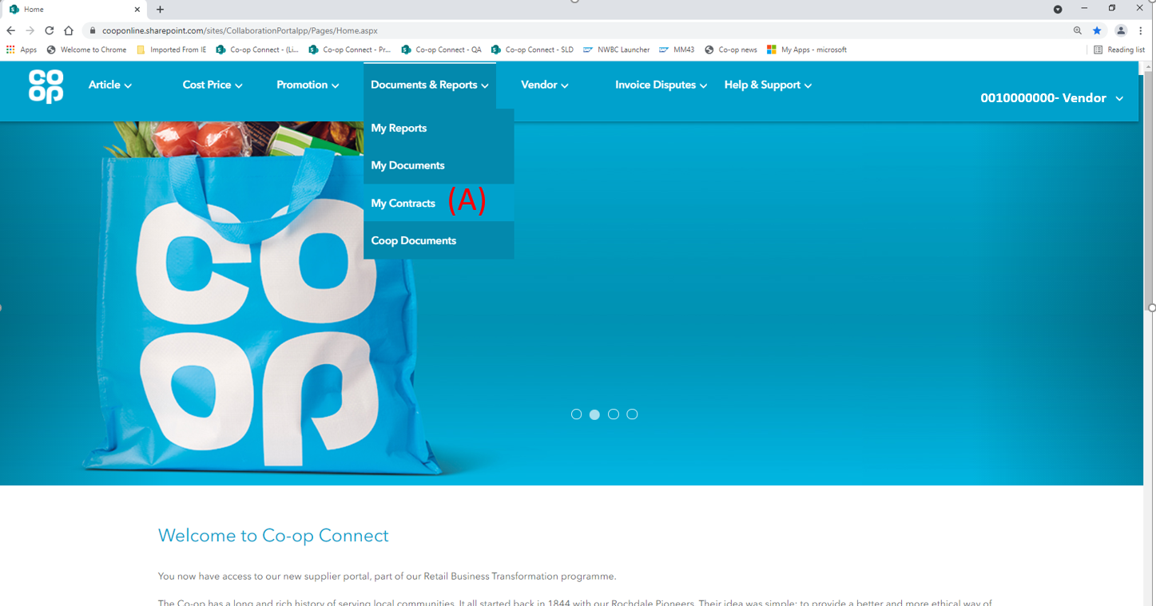
- Click on the ‘My Contracts’ option from the ‘Documents & Reports’ menu in the main header.

2.2. My Contracts
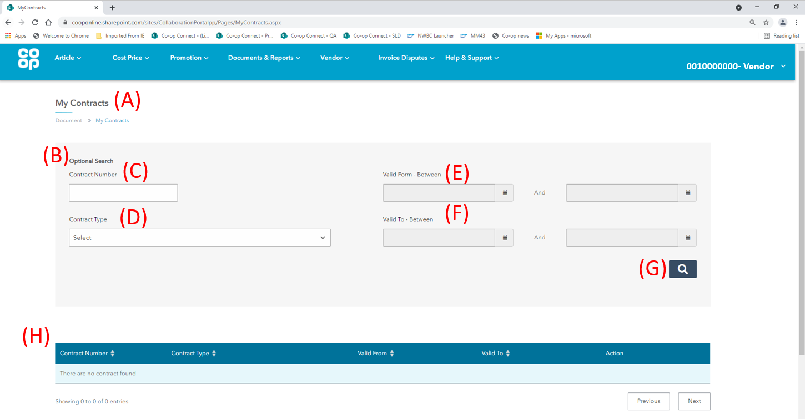

- My Contracts – the My Contracts screen is where suppliers can view the agreed supplier contracts with Co-op. Once in the screen, the user will need to complete the search before any contracts display in the table.

- Search – the user will need to populate at least one field within the Search outline and click the Search button (G) before options will appear in the table below. The table (H) will be empty until the user has completed the search functionality.
The search fields are as follows:

- Contract number – each contract will have a unique identifying number that is 10 digits long. Enter a contract number in this field to search for a specific contract. You must enter the full 10 digits to find your contract e.g. if your contract is 1234 you would need to enter 0000001234 to find your contract.

- Contract type – search by type of condition contract. For a full list of contract types and their definitions, please see section 1.2.

- Valid From – between – search by when a contract started by selecting a date in each of the ‘From’ fields. This will search for contracts that started between the dates specified.

- Valid To – between – search by when a contract finished by selecting a date in each of the ‘To’ fields. This will search for contracts that ended between the dates specified.

- Search – once at least one of the search fields have been filled in, click the search button to populate the table with contracts that match the criteria.

- Contract Table – this table will populate with contracts that match the search criteria. Before the search function has been used, the table will be empty.

3.0. View Contract
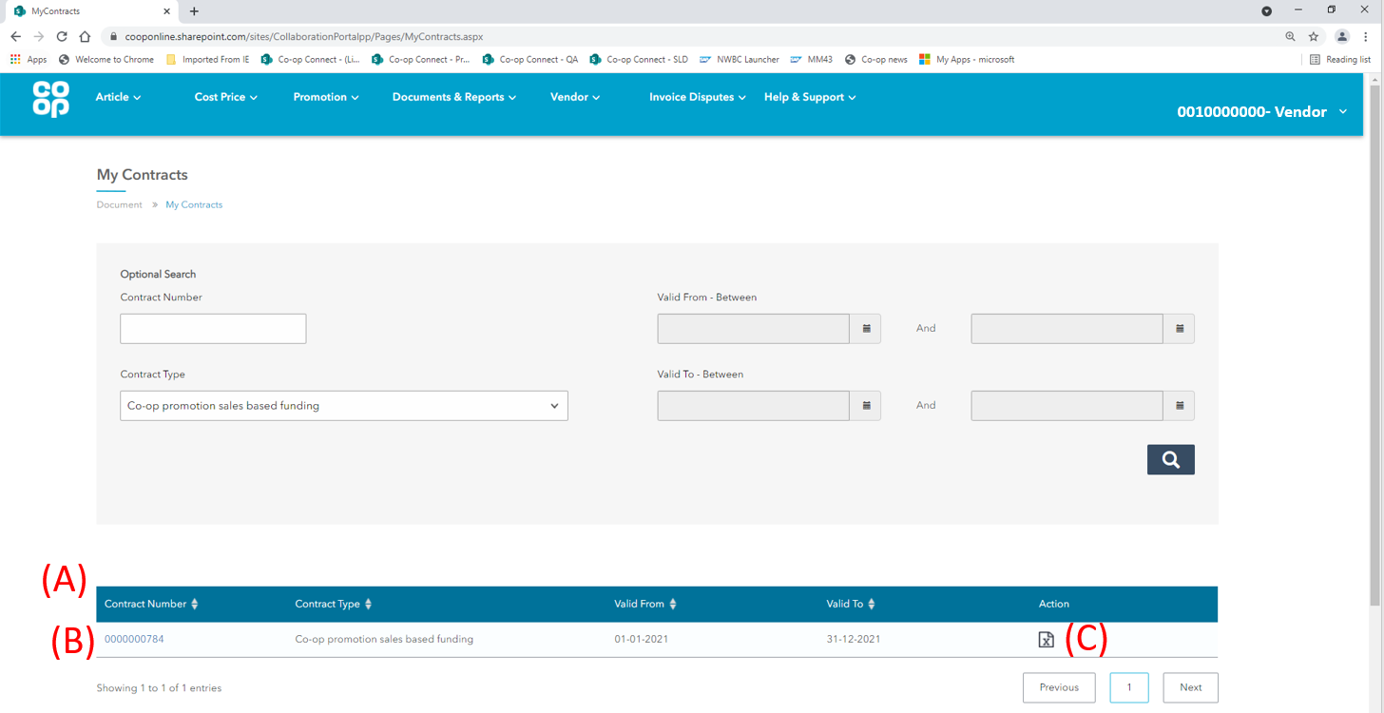
- Contract table – Once the search has been performed, all contracts that fall within the criteria will appear in the table. The table has the following 5 columns:
- Contract number
- Contract Type
- Valid From
- Valid To
- Action

To view a contract, click on either of the following:

- Contract Number – as shown in the above screenshot, the contract number will be blue and is available to click on. Clicking on it will open up the contract to view within the screens of Co-op Connect. Please see section 3.1 for more information.

- Action – each contract in the table will have the ‘extract’ icon in the action column:
This gives the user the option to view the contract in excel format. Please see section 3.2 for more information.

3.1. View Contract via Contract Number

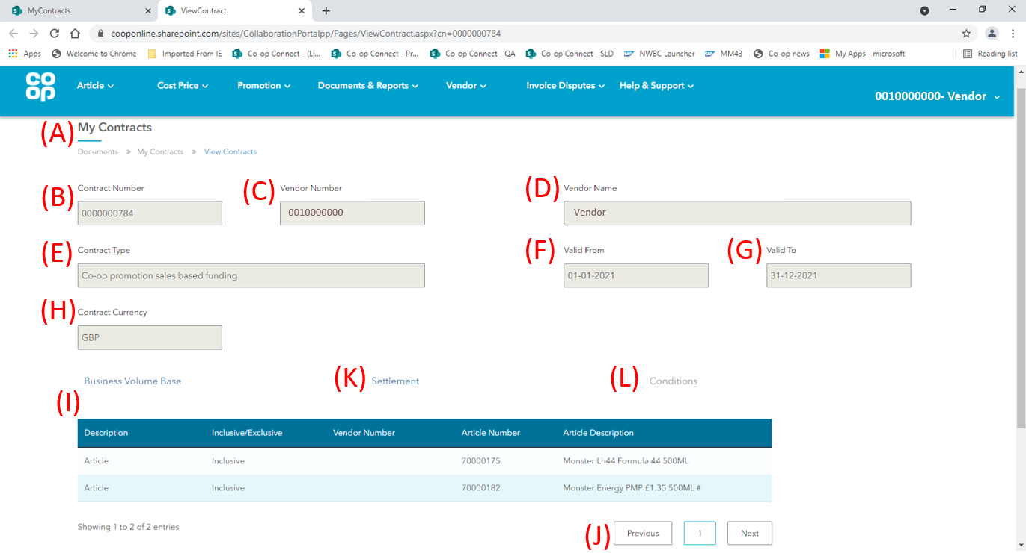
- My Contracts page – Once the user has clicked on the contract number in the table, a separate browser tab will open with the details of the contract. All the fields on this page are purely for display purposes and cannot be amended.

- Contract Number – each contract will have a unique identifying number that is 10 digits long. This field will display the contract number that was clicked on in the previous page.

- Vendor number – the unique SAP number given to each Vendor. This number will match the number in the top right corner of the screen.

- Vendor name – the name of your Vendor. Just like the Vendor number above, this will match the name in the top right corner of the screen.

- Contract type – this field will show the type of contract being displayed. For more information on contract types, please see section 1.2.

- Valid from – the date when the contract became valid.

- Valid to – the date when the contract will end.

- Contract currency – the currency which the contract will be invoiced in.

- Business Volume Base table – The business volume base is what the contract is being measured against. The page will open with the business base volume table already loaded. The table columns are as follows:
Column Header | Description
Description | The element that is either included or excluded from the contract, on which the business volume will be based. This will either show ‘Vendor’ or ‘Article’.
Inclusive/Exclusive | Defining whether the mentioned article or vendor on that row is included or excluded from the contract.
Vendor Number | If the description column shows ‘Vendor’ for the row, the Vendor number is displayed here. If your Vendor is split across multiple SAP Vendor numbers, you may see more than one Vendor number in this table.  This will be blank unless the ‘Description’ for that row reads ‘Vendor’.
Article Number | If the description column shows ‘Article’ for the row, the Article number is displayed here.  This will be blank unless the ‘Description’ for that row reads ‘Article’.
Article Description | If the description column shows ‘Article’ for the row, the Article description is displayed here.  This will be blank unless the ‘Description’ for that row reads ‘Article’.

- Business Volume base page numbers – If there are more than 10 rows in the business volume base table, they will display across multiple pages. These can be viewed by clicking on either ‘previous’ or ‘next’ or clicking directly on the page number.

- Settlement – the settlement table shows the dates of each settlement for the agreed contract. To view the settlement details, click on the Settlement button (J) and scroll down. Please see section 3.1.1. for more information.

- Conditions – the conditions table displays the conditions applicable to the contract. To view the condition details, click on the Conditions button (K) and scroll down. Please see section 3.1.2. for more information.

Due to the design of the screen, the Conditions button will only be available once the Settlement button has been clicked.

3.1.1. Settlement
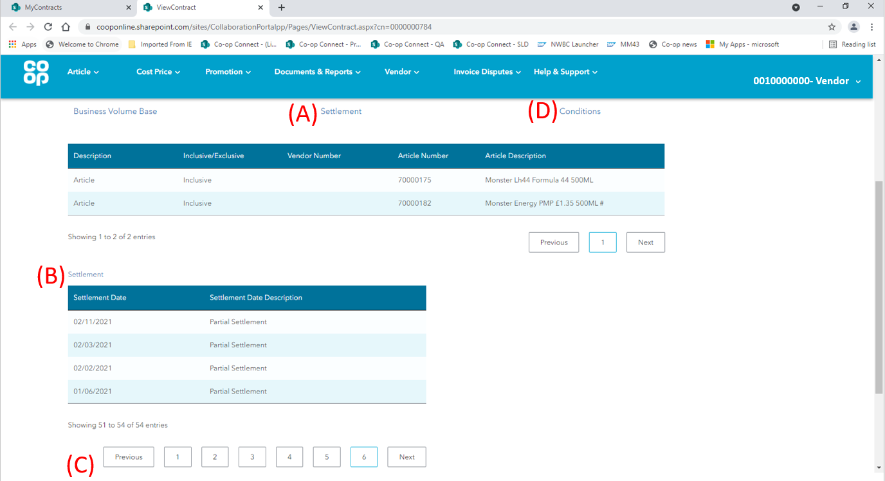
- Settlement button – to view the settlement details of the contract, click the Settlement button (A).

- Settlement table – the settlement table shows the dates of each settlement for the agreed contract. Once the Settlement button (A) has been clicked, the settlement details of the contract will display in their own table below the business volume base table. The columns in the table are as follows:

- Settlement date – the date of each settlement in the contract. The number of settlements will be the same as the number of invoices sent to the Supplier.

- Settlement Date Description – This shows the description of the settlement. There are 3 different types:
Settlement Type | Description
Partial | Any settlements before the final settlement (used to split out a settlement into smaller individual invoices)
Final | The final planned settlement of the contract
Delta | Any settlements that need to be invoiced after the final settlement (this is usually due to late business volume data)

- Settlement table page numbers - If there are more than 10 rows in the Settlement table, they will display across multiple pages. These can be viewed by clicking on either ‘previous’ or ‘next’ or by clicking directly on the page number.

- Conditions button – once the Settlement button (A) has been clicked on and the settlement details appear, the (D) conditions button will become blue and available for the user to click on. The user can now click on this to view the conditions table underneath the Settlement table.

3.1.2. Conditions
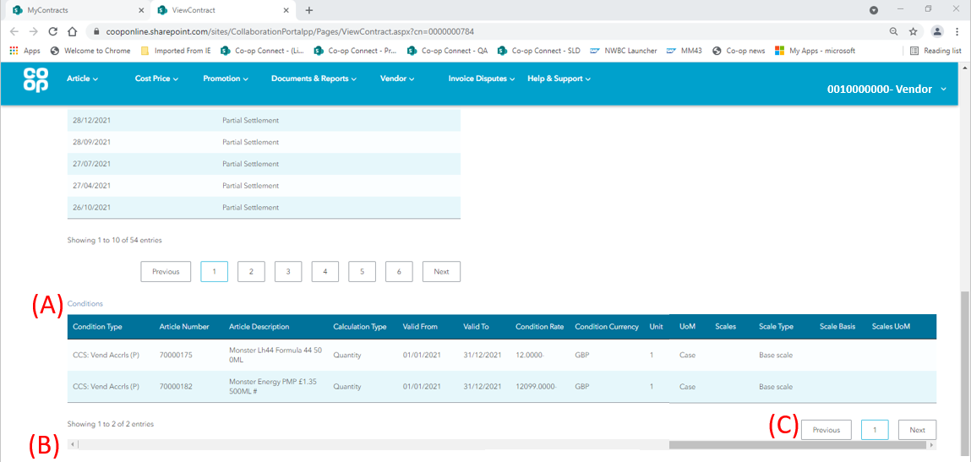
- Conditions table - the conditions table will display at the bottom of the page and shows the conditions applicable to the contract. The columns are as follows:

- Condition type – The codes displayed in this column are for internal purposes.

- Article number – if the condition is at an article level, this will display the article number that the condition is applicable to.

- Article Description – if the condition is at an article level, this will display the article description that the condition is applicable to.

- Calculation type – the calculation type will display if the condition of the contract is percentage, fixed amount or quantity based.

Calculation Type | Description
Percentage (%) | The total amount accumulated will be based on a percentage of business volume that is sold, purchased etc (depending on the contract type) through the duration of the contract.
Fixed Amount | The condition is based on a fixed amount.
Quantity | The total amount accumulated will be based on a quantity of business volume that is sold, purchased etc (depending on the contract type) throughout the duration of the contract.

- Valid From – the date that the specific condition is valid from.

- Valid to – the date that the specific condition is valid to.

- Condition Rate – the value based on the calculation type e.g., 5%.

- Condition Currency – if the condition rate is a monetary value, this will show the currency that the condition will be invoiced in. If the condition rate is a percentage, this will show ‘%’.

- Unit – if the calculation type is based on quantity, the unit column will display the number of UoMs required to trigger the specific condition.

- UoM – this describes the specific UoM that the unit quantity is applicable to. E.g.
(Unit) x (UoM) = 1 Case

- Scales – for contracts with a scale condition, this will show the upper limit of the number of UoMs that the specific condition will be applied to.

- Scales UoM – this describes the specific UoM that the scales quantity is applicable to. E.g.
(Scale) x (Scales UoM) = 1000 Cases

- Scale type – If the contract is scales based, this will show which type of scale that is being applied. Descriptions of the Scale Types are in the table below:
Scale Type | Description
Base scale | Different levels of funding are triggered against the total turnover e.g.  1-1000 sales = £1 back,  1001-2000 sales = £2 back  Total sales 2000  (£2x2000) = £4000 back
To scale | Different levels are funding are triggered against the turnover in each threshold e.g.  1-1000 sales = £1 back,  1001-2000 sales = £2 back  Total sales 2000  (£1x1000) + (£2x1000) = £3000 back

- Scale Basis - If the contract is scales based, this will show what the scale is measured in terms of. Descriptions of the Scale Bases are below.
Scale Basis | Description
Value scale | The scale is based on monetary value.
Quantity scale | The scale is based on a quantity of UoMs.

- Conditions table scroll bar – depending on the resolution of the screen, the user may see a scroll bar at the bottom of their screen. If so, please drag the scroll bar to see the later columns.

- Conditions table page numbers – If there are more than 10 rows in the conditions table, they will display across multiple pages. These can be viewed by clicking on either ‘previous’ or ‘next’ or clicking directly on the page number.
Please be aware that these may not be visible until the scroll bar has been moved across the to the right-hand side of the screen.

3.2. View contract via Excel extract
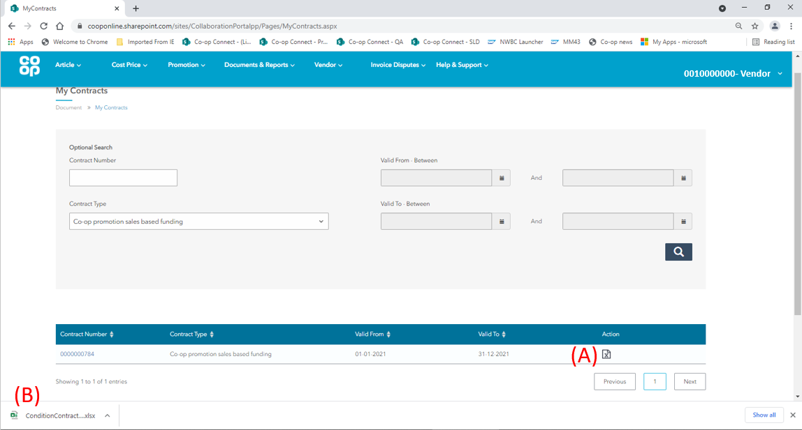
- Extract action icon – to view the condition contract details in an excel spreadsheet format, click on the extract button in the ‘Actions’ column.
All internet browsers will behave differently, the next few steps show using google chrome as the internet browser.

- Extract action icon – Once the user has clicked on the extract icon in the action table in the table, a small window option will appear at the bottom of the screen with ‘ConditionContractDetails’ as the file heading. This shows the user’s computer has downloaded a copy of the condition contract details.

Click on this option to open the excel file.

3.2.1. Excel extract – Header details tab
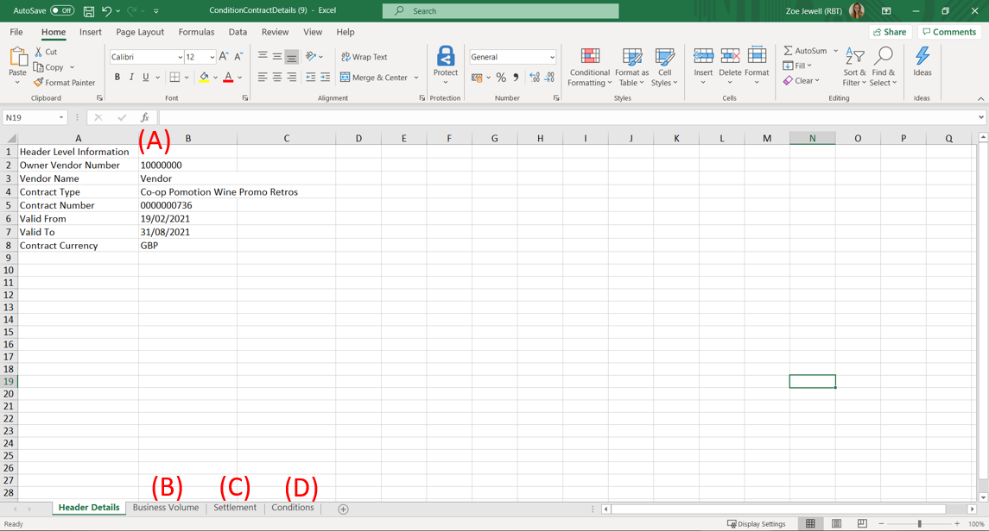
- Header level information – the excel is split in to 4 separate tabs, the first one being the header level information. This tab includes the following details:

- Vendor number – the unique SAP number given to each Vendor. This number will match the number in the top right corner of the screens in Co-op Connect.

- Vendor name – the name of your Vendor. Just like the Vendor number above, this will match the name in the top right corner of the screen.

- Contract Number – each contract will have a unique identifying number that is 10 digits long. This field will display the contract number that was clicked on in the previous page.

- Contract type – this field will show the type of contract being displayed. For more information on contract types, please see section 1.2

- Valid from – the date when the contract became valid.

- Valid to – the date when the contract will end.

- Contract currency – the currency which the currency is in.

- Business Volume Tab – click here to view the business volume information for the condition contract.

- Settlement tab - click here to view the settlement information for the condition contract.

- Conditions tab - click here to view the conditions information for the condition contract.

3.2.2. Excel extract – Business Volume tab
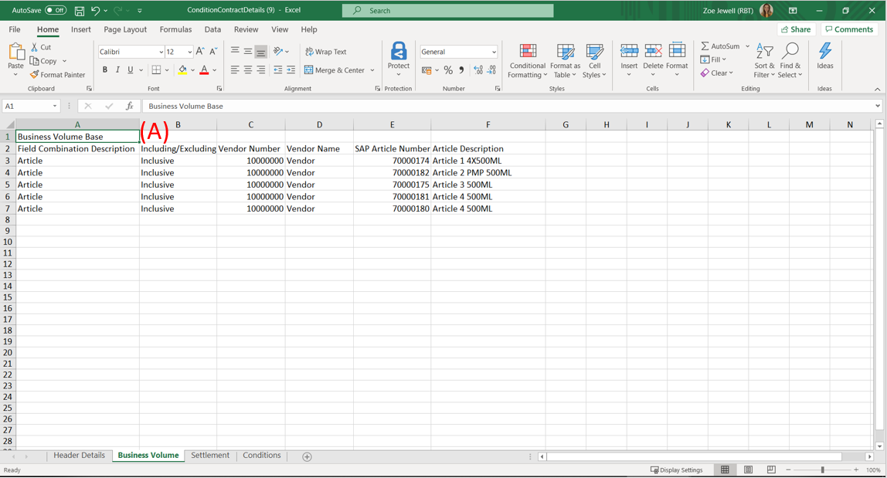
- Business volume base – The business volume base is what the contract is being measured against This tab displays the following information for the condition contract:
Column Header | Description
Description | The element that is either included or excluded from the contract, on which the business volume will be based. This will either show ‘Vendor’ or ‘Article’.
Inclusive/Exclusive | Defining whether the mentioned article or vendor on that row is included or excluded from the contract.
Vendor Number | If the description column shows ‘Vendor’ for the row, the Vendor number is displayed here. If your Vendor is split across multiple SAP Vendor numbers, you may see more than one Vendor number in this table.  This will be blank unless the ‘Description’ for that row reads ‘Vendor’.
SAP Article Number | If the description column shows ‘Article’ for the row, the Article number is displayed here.  This will be blank unless the ‘Description’ for that row reads ‘Article’.
Article Description | If the description column shows ‘Article’ for the row, the Article description is displayed here.  This will be blank unless the ‘Description’ for that row reads ‘Article’.

3.2.3. Excel extract – Settlements tab
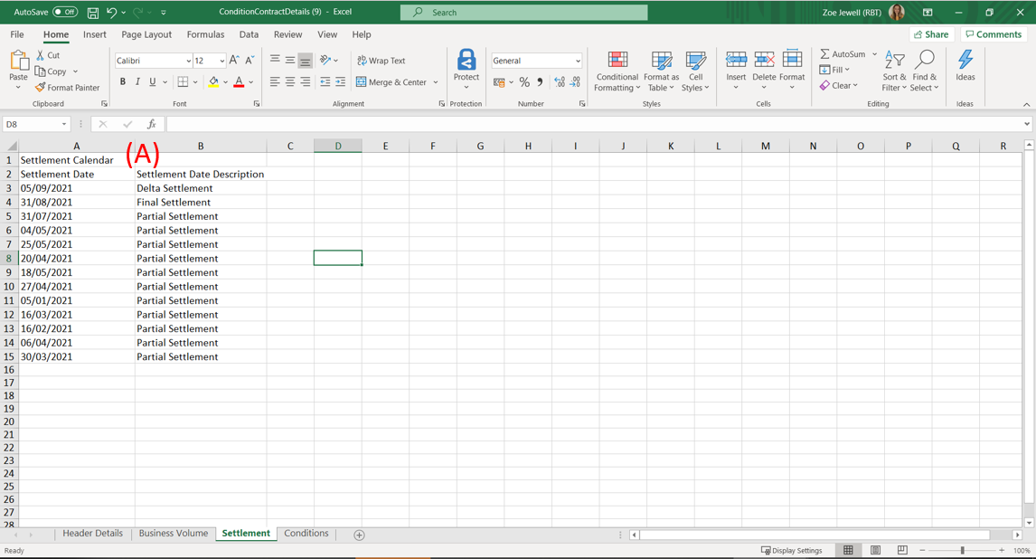
- Settlement table – The settlement tab shows the dates of each settlement for the agreed contract. The columns in the settlements tab are as follows:

- Settlement date – the date of each settlement in the contract. The number of settlements will be the same as the number of invoices sent to the Supplier.

- Settlement Date Description – This shows the description of the settlement. There are 3 different types:
Settlement Type | Description
Partial | Any settlements before the final settlement (used to split out a settlement into smaller individual invoices).
Final | The final planned settlement of the contract.
Delta | Any settlements that need to be invoiced after the final settlement (this is usually due to late business volume data).

3.2.4. Excel extract – Conditions tab
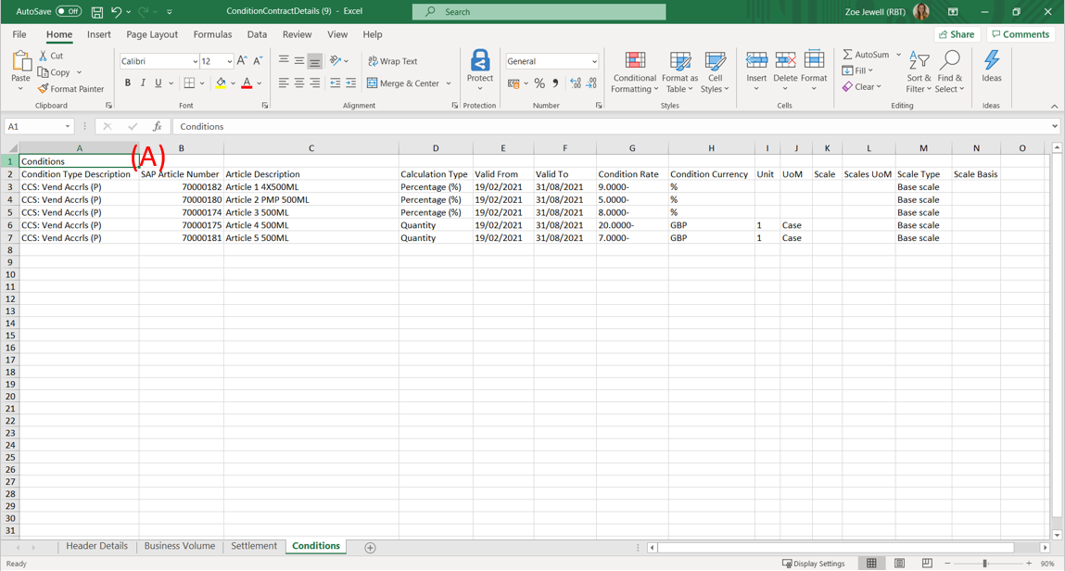
- Conditions - The conditions tab shows the conditions applicable to the contract. The columns are as follows:

- Condition type – The codes displayed in this column are for internal purposes.

- Article number – if the condition is at an article level, this will display the article number that the condition is applicable to.

- Article Description – if the condition is at an article level, this will display the article description that the condition is applicable to.

- Calculation type – the calculation type will display if the condition of the contract is percentage, fixed amount or quantity based.
Calculation Type | Description
Percentage (%) | The total amount accumulated will be based on a percentage of business volume that is sold, purchased etc (depending on the contract type) throughout the duration of the contract.
Fixed Amount | The condition is based on a fixed amount.
Quantity | The total amount accumulated will be based on a quantity of business volume that is sold, purchased etc (depending on the contract type) throughout the duration of the contract.

- Valid From – the date that the specific condition is valid from.

- Valid to – the date that the specific condition is valid to.

- Condition Rate – the value based on the calculation type e.g. 5%

- Condition Currency – if the condition rate is a monetary value, this will show the currency that the condition will be invoiced in. If the condition rate is a percentage, this will show ‘%’.

- Unit – if the calculation type is based on quantity, the unit column will display the number of UoMs required to trigger the specific condition.

- UoM – this describes the specific UoM that the unit quantity is applicable to.
E.g. (Unit) x (UoM) = 1 Case

- Scales – for contracts with a scale condition, this will show the upper limit of the number of UoMs that the specific condition will be applied to.

- Scales UoM – this describes the specific UoM that the scales quantity is applicable to. E.g.
(Scale) x (Scales UoM) = 1000 Cases

- Scale type – If the contract is scales based, this will show which type of scale that is being applied. Descriptions of the Scale Types are in the table below:
Scale Type | Description
Base scale | Different levels of funding are triggered against the total turnover e.g.  1-1000 sales = £1 back,  1001-2000 sales = £2 back  Total sales 2000  (£2x2000) = £4000 back
To scale | Different levels are funding are triggered against the turnover in each threshold e.g.  1-1000 sales = £1 back,  1001-2000 sales = £2 back  Total sales 2000  (£1x1000) + (£2x1000) = £3000 back

- Scale Basis - If the contract is scales based, this will show what the scale is measured in terms of. Descriptions of the Scale Bases are below
Scale Basis | Description
Value scale | The scale is based on monetary value
Quantity scale | The scale is based on a quantity of UoMs

