Co-op Connect Training
Create Article
Co-op Connect Training
Amend Article - Amend existing article details and view article change requests

Amend Article Contents
Co-op Connect training – Amend Article 3
1.0. Amend Article 3
Key points/ Top tips 3
1.1. Homepage 4
1.2. Amend Article 4
1.3. Amend Article – Article Details 6
1.3.1. Amend Article – Basic data 7
1.3.2. Amend Article – Life of Product 9
1.3.3. Category Specific Attributes – Wine (If selected) 10
1.3.4.. Category Specific Attributes – Other Alcohol (If selected) 11
1.3.5. Category Specific Attributes – Loose In-store Bakery (If selected) 11
1.3.6. Category Specific Attributes – Loose produce (If selected) 12
1.3.7. Category Specific Attributes – Laundry (If selected) 12
1.3.8. Category Specific Attributes – CD’s, DVD’s and Games (if selected) 13
1.4. Restrictions 13
1.5. Unit of Measure 16
1.5.1. Amending existing information e.g. changing case dimensions and adding new barcodes 17
1.5.2. Adding new units e.g. adding a new case size 19
1.6. Amend Article - Barcode Linking 19
Reminder of terms 20
1.6.1. Amend article - New barcode relationship 20
1.7. Amend Article - Purchasing details 21
1.7.1. Amend Article – Purchasing details (Cost price) 22
2.0. View Amend Article change request 24
Key points/ Top tips 24
2.1. Homepage 24
2.2. My Change Requests 24
2.3. Extracted Form 27

Co-op Connect training – Amend Article
This training guide will show the details of:
- Amending existing article details
- Viewing article change requests

1.0. Amend Article

Amending an article includes:
- Adding a new case size
- Amending article details
- Adding a new barcode

Key points/ Top tips

- Amending an article can be done by clicking the notepad and pen icon in the ‘actions’ column of the tables in either of the ‘Amend Article’ or ‘My Articles’ screen

- For more information on specific fields, please visit the ‘Create Article’ guide

- The rules and validations for amending existing articles differ depending on the status that the articles are in. This will be outlined throughout the guide.

- The NSL and barcodes can be found by opening the extract of the change request. The codes will be populated on the 2nd and 3rd tabs

1.1. Homepage
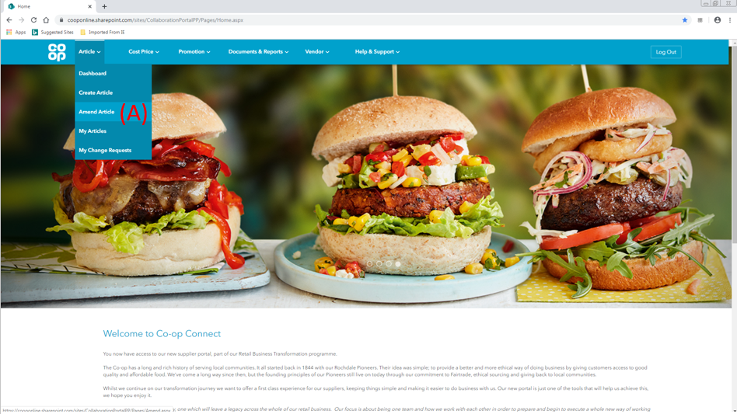
- Click on the ‘Amend Article’ option from the ‘Article’ menu in the main header

1.2. Amend Article
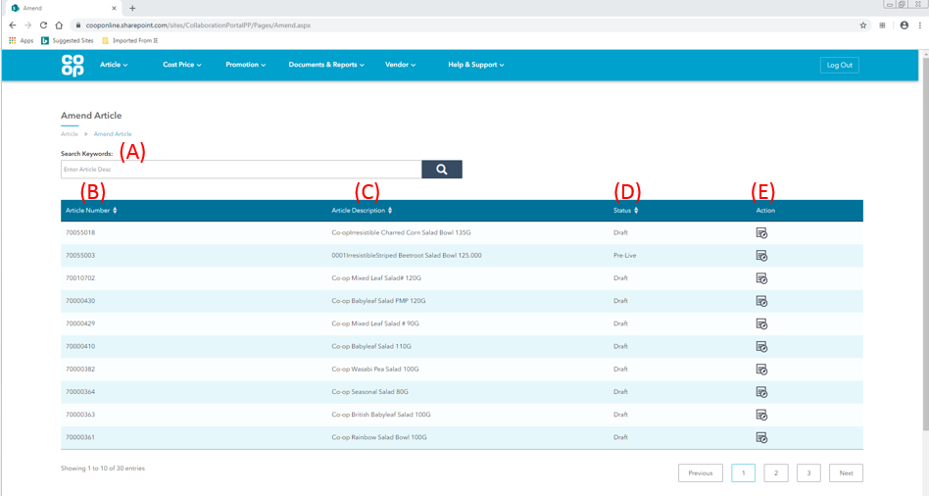

- Search Keywords - The ‘Search keyword’ bar can be used to find specific lines by searching for an article’s description

- Article Number - This column displays the SAP article number of each article. An article number is a unique ID given to any article that is in our SAP system, which is generated and assigned once the article has been through the approval process.

- Article description - The article description column will show the description that we hold in SAP for the article.

- Status - This shows the status of the article in our SAP system. For a full list of statuses, please see the table below:
Status | Description
Draft | The article is in our system but has not had cost price information submitted by the vendor or approved by the buyer
Pre-Live | The article is in our system with cost price information, but has not yet been ranged or ordered
Live | The article is in our system with cost price information, and is currently ranged and being ordered
Seasonal Discontinued | A seasonal line that has been discontinued. Articles in this status will not be available to amend.
Intend to Discontinue | This article has started process of becoming discontinued. Articles in this status will not be available to amend.
Discontinued | This line has been discontinued and is unavailable for Co-op to order. Articles in this status will not be available to amend.
Seasonal out-of-range | A seasonal line that is not currently in the range. Articles in this status will not be available to amend.

- Action – The amend article icon will be in this column, as is a notepad with pen, please see below. Click on this icon for the article that needs to be amended.

1.3. Amend Article – Article Details

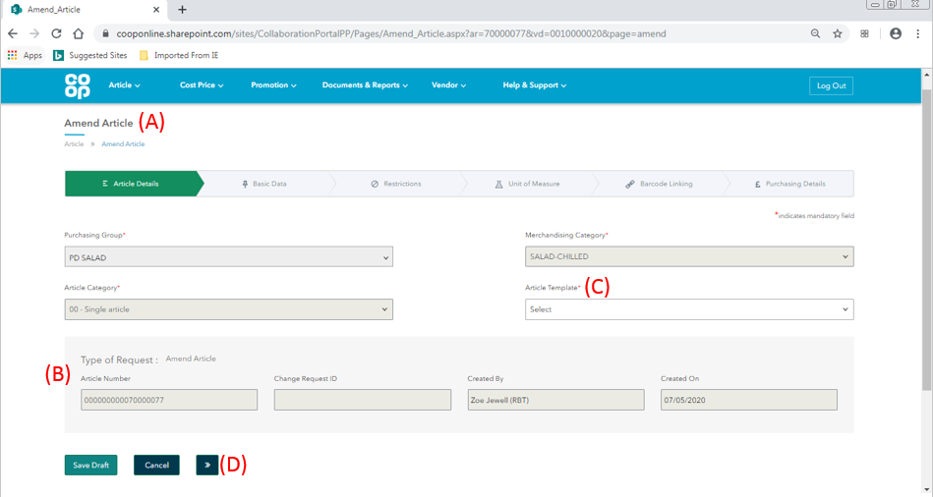
- Amend article – By clicking the icon, you will be taken to the ‘Amend Article’ screen. Some of the fields in the tabs will be populated with the information that Co-op holds in SAP for the article selected.

Fields on this screen that will be pre-populated on an amend article change request:
- Purchasing Group
- Merchandising Category
- Article Category
- Article Number
- Created By
- Created on

- Type of Request – These fields will be pre-populated with:
- The SAP Article number which is generated and assigned once the article has been through the approval process.
- The name of the user who first created the article
- The date when the article was created

- Article template – The article template will need to be selected as this is not saved in SAP. Please select the template that the article belongs to. This will affect the available fields in the amend article form. Depending on the article template selected, extra fields and validations will become active when filling out the ‘Amend Article’ form. Please see the full list below:

Article template | Extra available fields or validations associated with template
General | This is the default template and should be used for any articles that do not fall within one of the exceptions below
Wine | - Wine Type  - ABV%  - Excise Duty rate  - Country of origin  - Country of Consignment  - Third Country of origin  - Taste notes (1-5)
Other Alcohol | - ABV%  - Excise Duty Rate
In-Store Bakery | - Contains  - Energy
Loose Produce | - Variety  - Class  - Country of origin
Laundry | - Number of Washes
CD’s, DVD’s and Games | - For Sale from
Flat pack Free Standing Display Unit | No extra fields, extra field validations
Service Article | No extra fields, extra field validations
Filled/partially filled free standing display unit (FSDU) | No extra fields, extra field validations

Please select an article template

- Navigation arrow – Once an Article template has been selected, please click the navigation arrow to move to the next tab

For more information on specific fields, please visit the ‘Create Article’ guide

1.3.1. Amend Article – Basic data

Fields on the basic data tab (first section only) that will be pre-populated with the data that is held in SAP on an amend article change request:
- Brand
- Sub- brand
- Product descriptions 1&2
- Selling unit size
- Gross and Net contents
- VAT code
- Price marked Pack and Value
- Extra free pack
- Catchweight indicator
- Delivery method (Depot or direct)

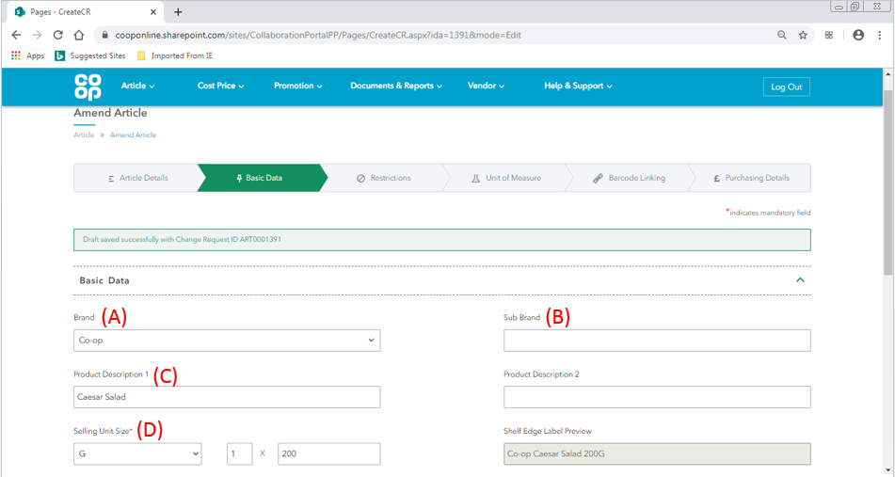

In the screenshot above, the following fields can be amended:
- Brand – If the brand required isn’t available in the dropdown list, please contact your Buyer.
- Sub-brand
- Product descriptions 1&2
- Selling unit size – if the selling unit of an article is changing in size by more than 10%, a new article should be created. The new article should be linked to the existing article using the ‘standard article number’ field.

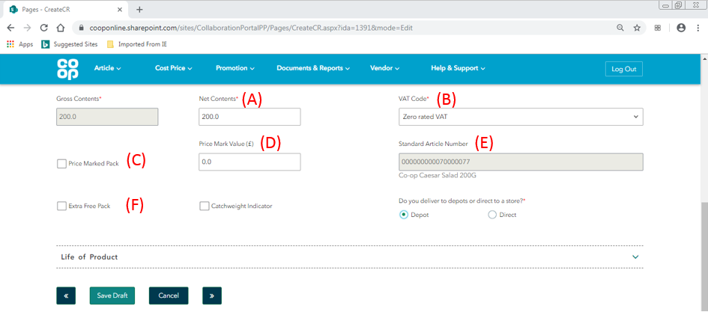

In the screenshot above, the following fields can be amended:
- Net contents
- VAT Code
- Price Marked Pack (draft and pre-live articles only)
- Price Mark Value (draft and pre-live articles only)
- Extra Free Pack (draft and pre-live articles only)

Non-amendable fields:
- Standard article number – This field will either display:

- The article number and description of the article being amended (if the standard article number field was left blank during the articles creation). If this field was left blank during the articles creation, the article will become the standard version of itself. This field will therefore auto-populate with its own article number and description.

- The article number and description of the linked standard article (this will have been entered during the articles creation). The field will show the article number and description of the linked article.

For more information on specific fields, please visit the ‘Create Article’ guide

1.3.2. Amend Article – Life of Product
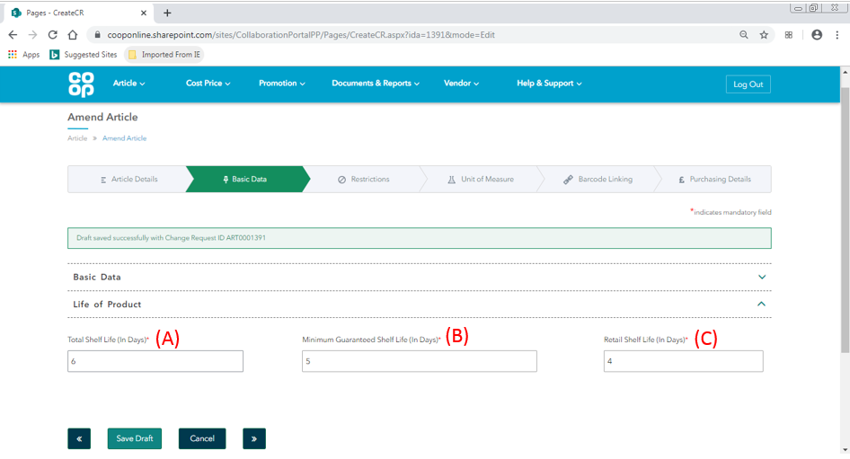

In the screenshot above, the following fields will be pre-populated on an amend article change request and can also be amended:
- Total Shelf Life
- Minimum Guaranteed Shelf Life
- Retail Shelf Life

For more information on specific fields, please visit the ‘Create Article’ guide

1.3.3. Category Specific Attributes – Wine (If selected)

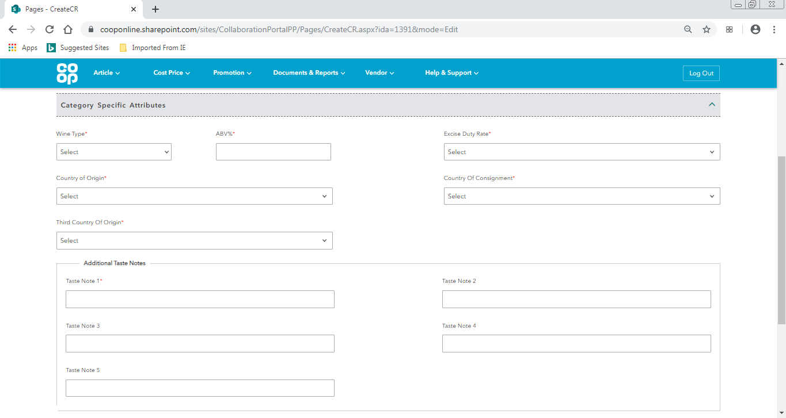

All of the fields included in the Wine template will be pre-populated with the information that SAP holds for the article. All of these fields can be amended:
- Wine Type
- ABV%
- Excise Duty rate
- Country of origin
- Country of Consignment
- Third Country of origin
- Taste notes (1-5)

1.3.4.. Category Specific Attributes – Other Alcohol (If selected)
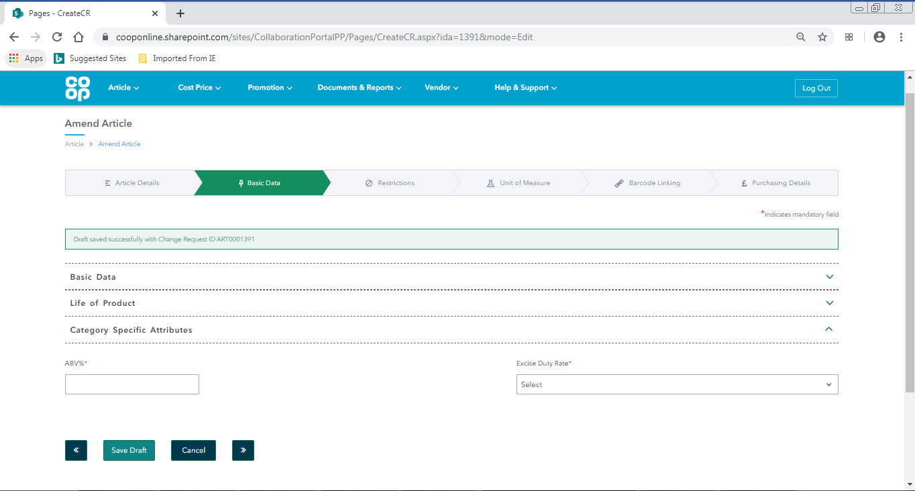
The fields included in the Other Alcohol template will be pre-populated with the information that SAP holds for the article. Both fields can be amended:
- ABV%
- Excise Duty Rate

1.3.5. Category Specific Attributes – Loose In-store Bakery (If selected)
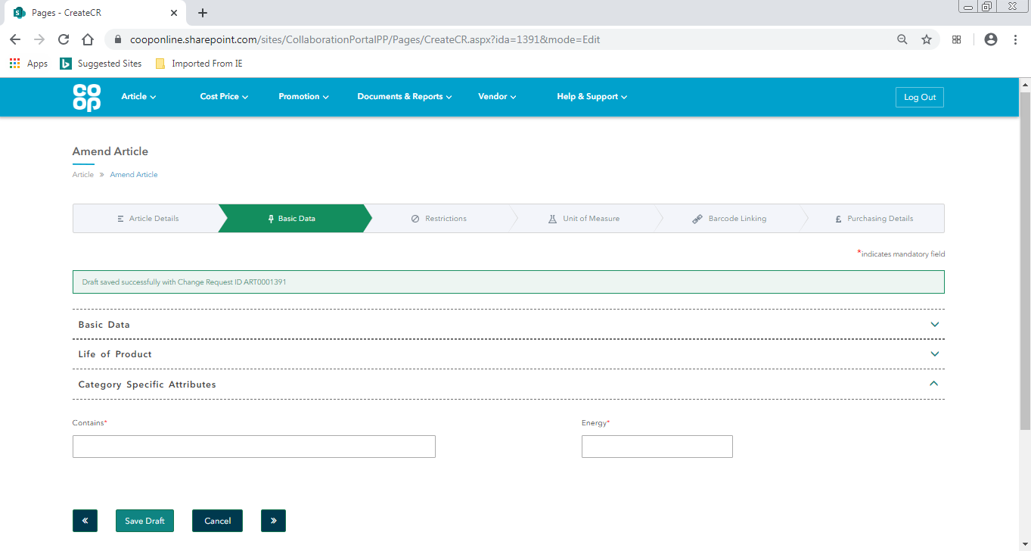

The fields included in the loose in-store Bakery template will be pre-populated with the information that SAP holds for the article. Both fields can be amended:
- Contains
- Energy

1.3.6. Category Specific Attributes – Loose produce (If selected)
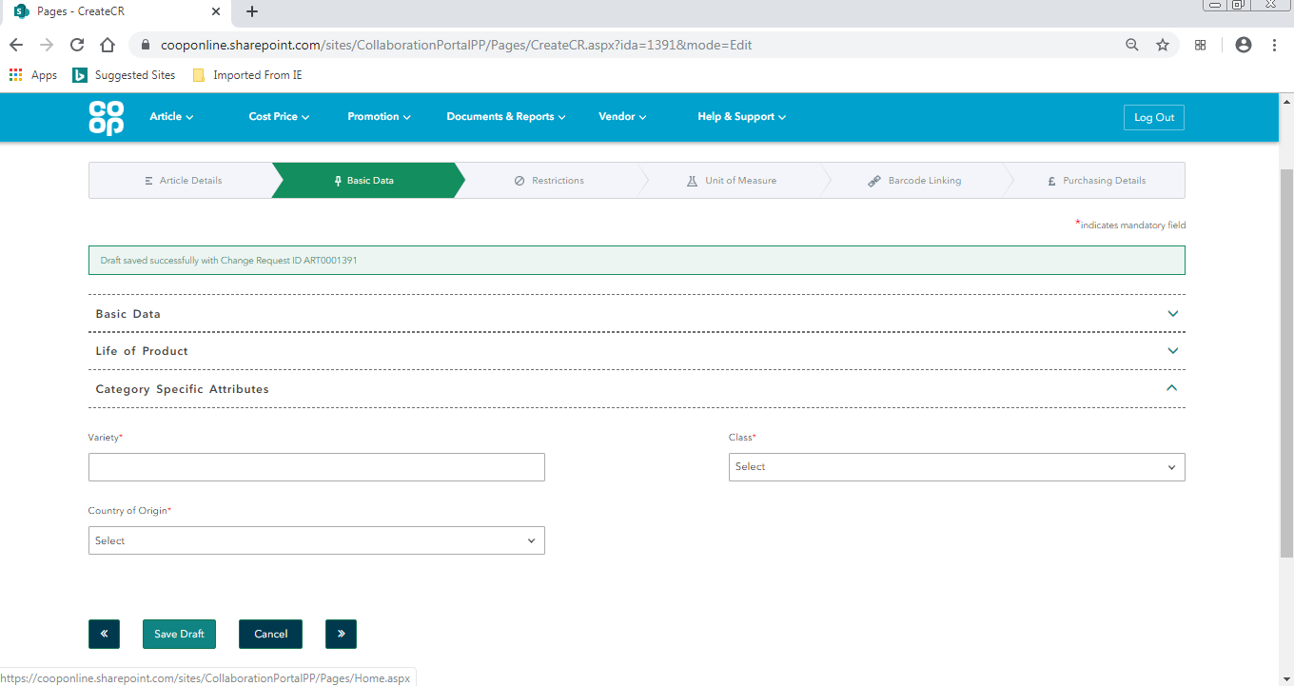

The fields included in the loose in-store Bakery template will be pre-populated with the information that SAP holds for the article. All fields can be amended:
- Variety
- Class
- Country of Origin

1.3.7. Category Specific Attributes – Laundry (If selected)
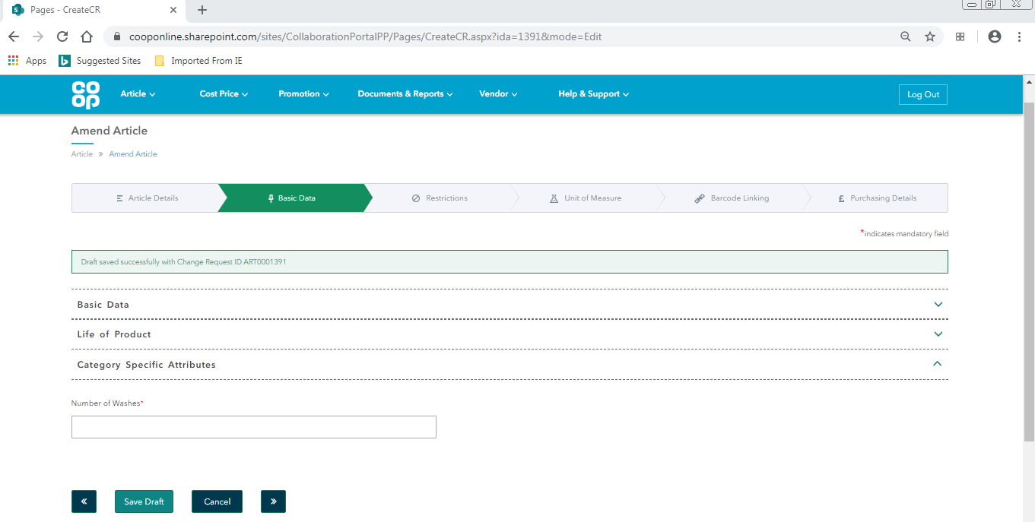

The field included in the laundry template will be pre-populated with the information that SAP holds for the article. The field can be amended:
- Number of Washes

1.3.8. Category Specific Attributes – CD’s, DVD’s and Games (if selected)

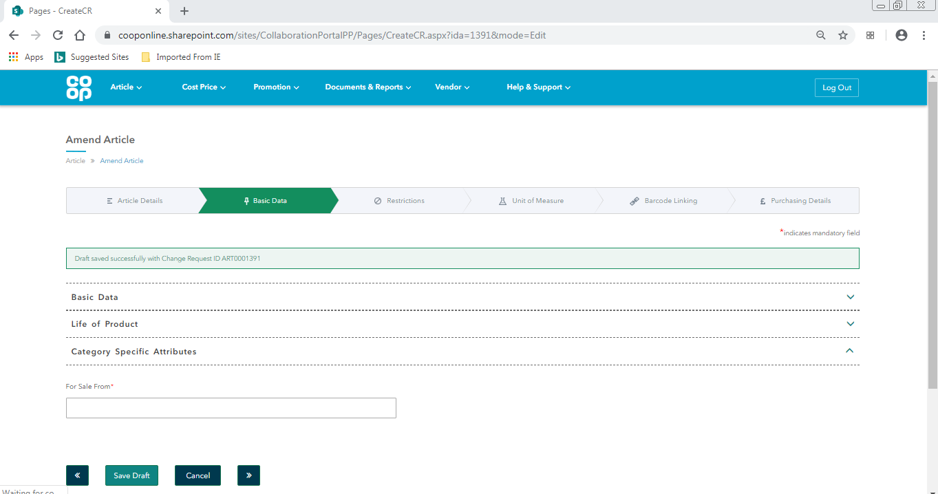

The field included in the CDs, DVDs and Games template will be pre-populated with the information that SAP holds for the article. The field can be amended:
- For Sale From

For more information on specific fields, please visit the ‘Create Article’ guide

1.4. Restrictions

Every field on the Restrictions tab will be pre-populated with the information that SAP currently holds for the article.

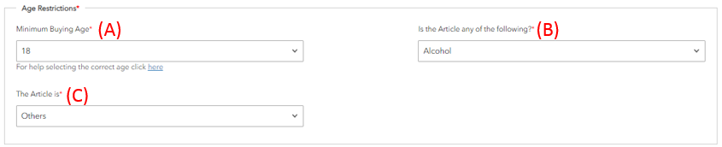

In the screenshot of the Age Restrictions outline above, the following fields can be amended:
- Minimum buying age (draft and pre-live articles only)
- Is the article any of the following?
- The article is?

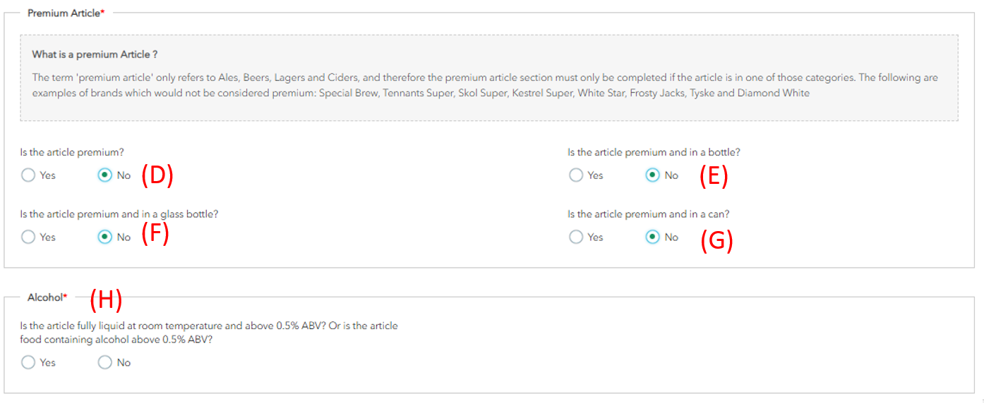
In the screenshot of the Premium Article outline above, the following fields can be amended:
- Is the article premium?
- Is the article premium and in a bottle?
- Is the article premium and in a glass bottle?
- Is the article premium and in a can?
- Alcohol – is the article fully liquid at room temperature and above 0.5% ABV? Or is the article food containing alcohol above 0.5% ABV?
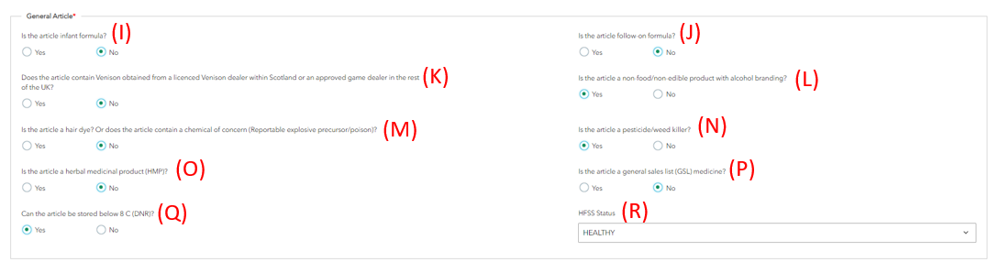
In the screenshot of the General Article outline above, the following fields can be amended:
- Is the article infant formula?
- Is the article follow on formula?
- Does the article contain Venison obtained from a licenced Venison dealer within Scotland or an approved game dealer in the rest of the UK?
- Is the article a non-food/non-edible product with alcohol branding?
- Is the article a hair dye? Or does the article contain a chemical of concern (Reportable explosive precursor/poison)?
- Is the article a pesticide/weed killer?
- Is the article a herbal medicinal product (HMP)?
- Is the article a general sales list (GSL) medicine?
- Can the article be stored below 8°C (DNR)?
- HFSS Status
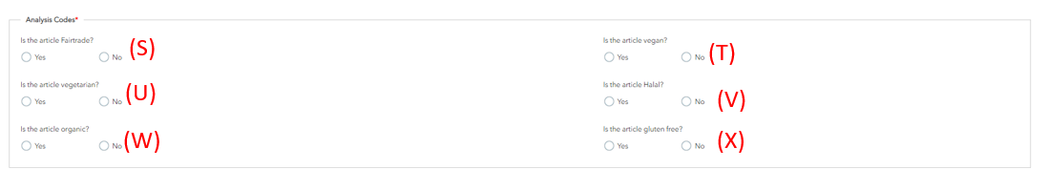

In the screenshot of the analysis codes outline above, the following fields can be amended:
- Is the article fairtrade?
- Is the article Vegan?
- Is the article Vegetarian?
- Is the article Halal?
- Is the article organic?
- Is the article gluten free?

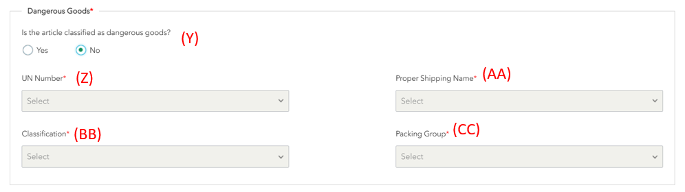
In the screenshot of the Dangerous goods outline above, the following fields can be amended:
- Is the article classified as dangerous goods?
- UN Number (draft and pre-live articles only)
- Proper Shipping name (draft and pre-live articles only)
- Classification (draft and pre-live articles only)
- Packing Group (draft and pre-live articles only)

For more information on specific fields, please visit the ‘Create Article’ guide

1.5. Unit of Measure

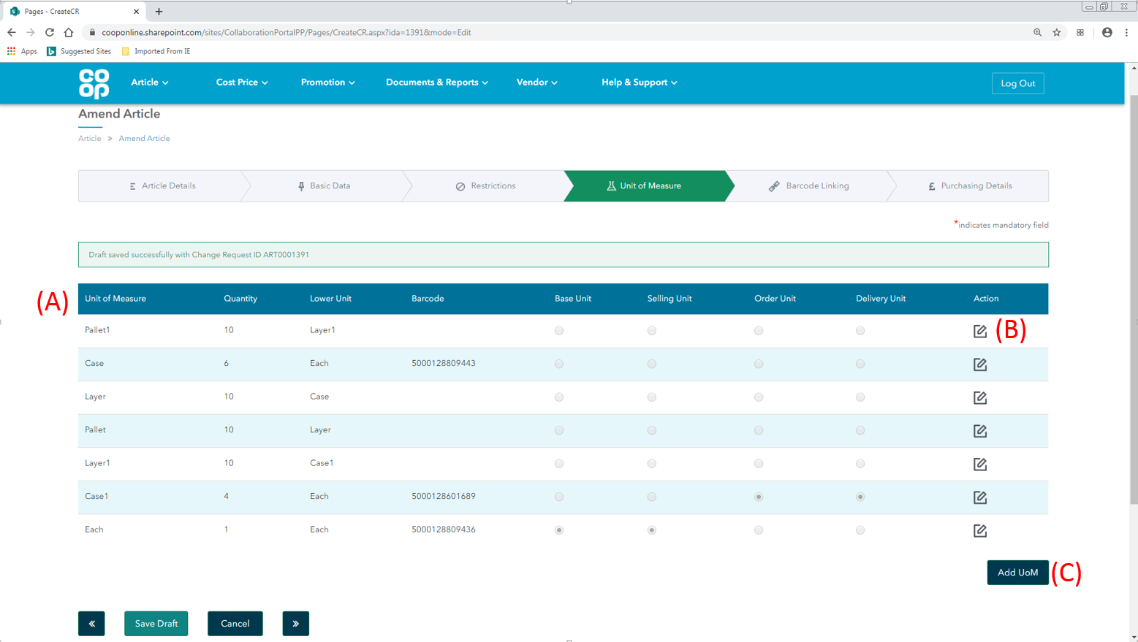

For amending the unit of measure screen, there are 2 possible actions available:
- Amending existing information e.g. changing case dimensions and adding new barcodes
- Adding new units e.g. adding a new case size
If existing Layer and Pallet quantities need to be amended, this can not be actioned in Co-op Connect. Please contact your Buyer.

- Unit table – the unit table will be populated with all of the units that are associated with the article that is being amended

- Amend icon - to amend existing article information, click on the notepad icon.

- Add UoM – to add a new unit of measure to an article, click on the ‘Add UoM’ button

1.5.1. Amending existing information e.g. changing case dimensions and adding new barcodes

Once the amend icon has been clicked for a unit, a pop up window will appear with all of the current details held for that unit.
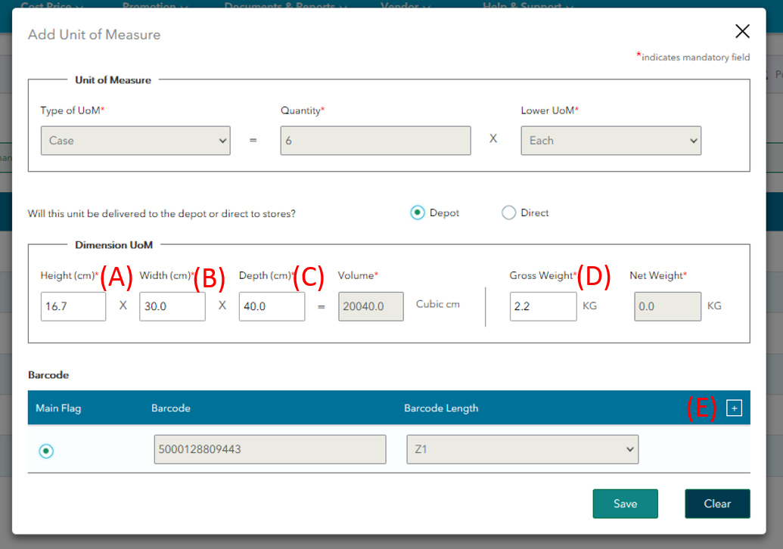

In the unit of measure pop up above, the following fields can be amended:
- Height
- Width
- Depth
- Gross Weight

To add a new barcode:
- New Barcode – click the [+] button in the corner of the barcode table to open a new row

If a new barcode is being added to a Co-op branded article:
The table will now look similar to the below. For Co-op branded articles, the Co-op will provide a barcode. Please follow the steps below to request a new barcode for the unit –
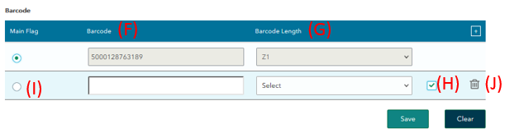

- Barcode field – Please leave this blank

- Barcode Length – Please select from the dropdown menu the length/ type of barcode needed for the unit. If unsure, please contact your buyer.

- Tick/ Check button – Once the barcode length field is selected, please click the ‘Check’ button. This will populate the ‘Barcode’ field with the requested barcode from Co-op.

- Main Flag – this will be unavailable to select. The Co-op team will switch the new barcode to be the main barcode internally on the date required.

- Bin/ Delete – if a mistake has been made, please use the Bin icon to delete the line from the barcode table

If a new barcode is being added to a branded article:
The table will now look similar to the below. For articles that are not Co-op branded (including non-branded articles) the supplier will provide the barcode. Please follow the steps below to provide a new barcode for the unit -

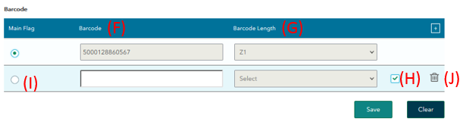
- Barcode field – Please enter the barcode of the unit

- Barcode length – this field will be greyed out, please leave blank

- Tick/ Check button – Once the barcode field has been completed, please click the ‘Check’ button. Once the barcode is verified in Co-op’s system, both the ‘barcode’ and ‘barcode length’ field will grey out

- Main Flag – this will be unavailable to select. The Co-op team will switch the new barcode to be the main barcode internally on the date required.

- Bin/ Delete – if a mistake has been made, please use the Bin icon to delete the line from the barcode table

Once all the steps have been completed, click the ‘Save’ button to save the new barcode to the unit.

1.5.2. Adding new units e.g. adding a new case size

Once the ‘Add UoM’ button has been clicked, a blank ‘Add Unit of Measure’ window will pop up. Please complete the information required on the pop up and press ‘Save’ to save the new unit on to the table.
For more information on adding a new unit, please visit the ‘Create Article’ guide

Once all of the new units have been added to the table, there are no more steps to be completed on this page. The ‘base’, ‘selling’, ‘order’ and delivery’ radio buttons cannot be amended by the vendor - these will be changed by Co-op’s internal supply chain team. Please click the navigation buttons to progress to the next page.

1.6. Amend Article - Barcode Linking

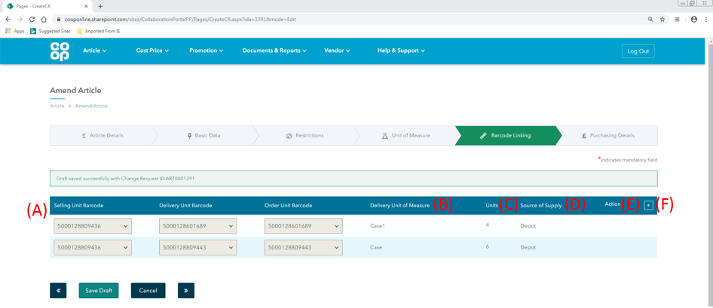

The barcode linking tab is unique to the amend article screens. This tab is used to create relationships between the units that have been created on the previous Unit of Measure tab. The barcode linking screen supports NSL creation.

If any new barcodes or units have been added on the Unit of Measure screen, a new relationship will need to be built in this tab. Existing relationships won’t be available to amend.

- Barcode relationship table – the table will display how each of the barcodes that have been added in the previous tab link together

- Delivery unit of measure – the unit shown in this column will be the unit associated with the delivery unit barcode selected
- Units – the quantity of base units within the Delivery unit
- Source of supply – this column displays where the delivery unit will get delivered. This will show either ‘Depot’ or ‘Direct’.

- Action – there will be no available actions for existing relationships. A bin icon will be present for new relationships that have not yet been submitted and approved.

- [+] – Click this button to add a new relationship to the table.

A user will be unable to continue to the last tab to submit if new barcodes or units have been added in the unit of measure screen and not included in this tab.

Reminder of terms
- Selling Unit = The selling unit can be described as the individual unit that the Co-op will sell to a customer. Each selling unit equals one beep at the till (Selling unit has previously been known as a consumer unit)

- Order Unit = The order unit is the unit that the Co-op will order from their suppliers. E.g. Co-op wouldn’t order each individual chocolate bar, instead they would order a case of 36 chocolate bars, which would then each be sold as 36 individual selling units (Order Unit has previously been known as Traded Unit).

- Store/ Delivery Unit = The store delivery unit is the unit that will be delivered to Co-op stores (in most cases, this will be the same as the order Unit). A store delivery unit differs from the Order Unit if the stock that the supplier sends in the depot is then split up when sent to stores. An example of this is cigarettes – Co-op will receive a case of Cigarettes that holds 10 individual sleeves of cigarettes which we will then send to stores.

1.6.1. Amend article - New barcode relationship
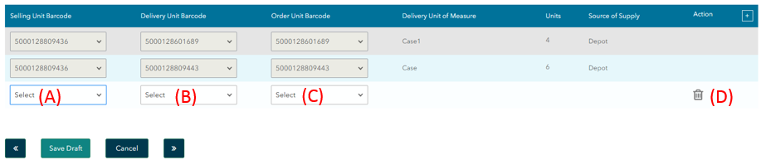

Once the [+] button has been clicked, a new blank row will appear in the table

- Selling unit barcode – select from the dropdown menu the correct selling unit barcode for this relationship.

- Delivery unit barcode – Once the selling unit barcode has been selected, any barcodes that have been recognised as possible store delivery unit barcodes will be available in the delivery unit barcode dropdown field. The barcodes will be ordered oldest to newest (the most recently added will be at the bottom).

Select the delivery unit barcode for this relationship.

Once this barcode has been selected, the ‘Delivery unit of measure’ and ‘Units’ columns will auto-populate with the information that’s associated to the barcode chosen.

- Order unit barcode – Once the delivery unit barcode has been selected, any barcodes that have been recognised as possible order unit barcodes will be available in the order unit barcode dropdown field. Select the order unit barcode for this relationship.

- Bin icon – use the bin icon to delete the new row if needed.

Each row in this table represents an NSL code. If a new barcode is being added, a new row should be added for each new NSL code expected.

Once all of the barcodes from the unit of measure tab have been included in a relationship, click on the >> next arrows to progress to the next page.

1.7. Amend Article - Purchasing details

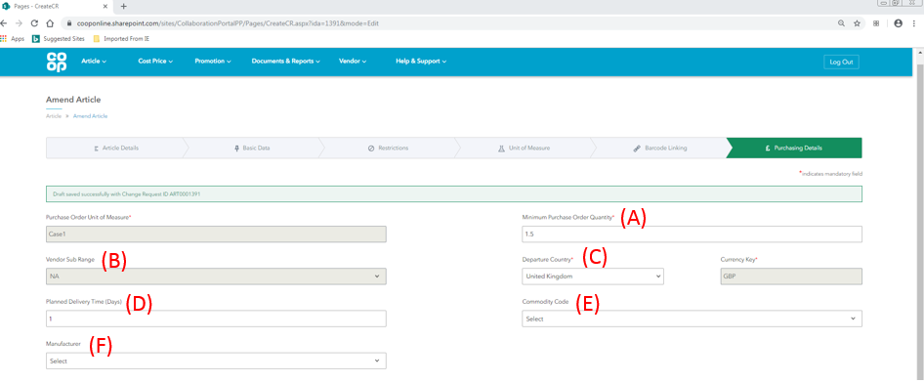
Fields on this screen that will be pre-populated on an amend article change request:
- Purchase Order unit of measure
- Minimum Purchase order quantity
- Vendor sub-range (if available to the vendor)
- Departure country
- Currency key
- Planned delivery time
- Commodity code (if originally completed)
- Manufacturer (if originally completed)

The following fields included in the above screenshot of the purchasing details tab are available to amend:

- Minimum purchase order quantity – the quantity entered in this field will be in terms of the unit displayed in the ‘Purchase order unit of measure’ field.
- Vendor sub range (if available)
- Departure country
- Planned delivery time
- Commodity code
- Manufacturer

For more information on specific fields, please visit the ‘Create Article’ guide

1.7.1. Amend Article – Purchasing details (Cost price)
The cost price section of the purchasing details tab only needs to be completed if new unit(s) have been added as part of the amend change request.

If a new unit has been added as part of the amend change request:

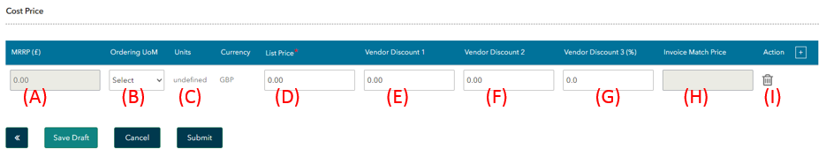

- MRRP - (Manufacturers Recommended Retail Price) - If an article is branded (not Co-op’s own brand) it is mandatory for the Vendor to provide a recommended retail price for each article in the proposal. The MRRP value is against a single selling unit.

- Ordering UoM – select the new unit from the dropdown menu that was created as part of the amend article change request.

- Units – Once the ordering unit of measure has been selected, the units column will populate with the quantity of base units in the order unit.

- List price - Please provide the cost price of the unit selected. The value entered should be:
- a monetary value
- a numeric value only
- Vendor discount 1 (currency) – a monetary discount (not linked to a promotion) that will be applied to the invoice price

- Vendor discount 2 (currency) – a second monetary discount (not linked to a promotion) that will be applied to the invoice price

- Vendor discount 3 (percentage) – a percentage discount (not linked to a promotion) that will be applied to the invoice price

- Invoice match price - the total cost of the unit once the vendor discounts have been applied

- Action - The bin icon in each row allows a unit to be removed from the cost proposal

If no new units have been added as part of the amend change request:

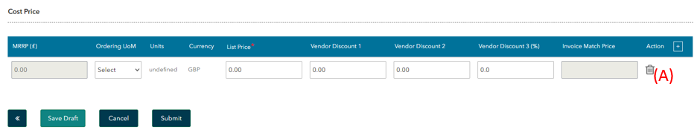

If no new units have been added as part of the amend article change request, the cost price section does not need to be completed.

- Bin - The blank row should be deleted by clicking on the bin icon in the action column. Once this row has been deleted, the user will be able to submit the amend article change request.

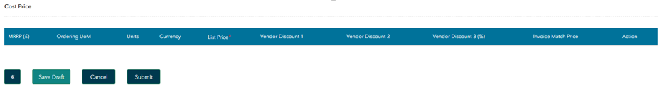

The table in the cost price section will now be empty and look like the screenshot above.

Once all the information is complete, click the Submit button. This will send the Amend Article Change Request to your buyer for review.

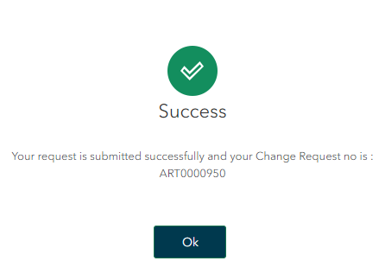

A success popup window will appear with the Change Request number for the amend article proposal - this will be in the format of: ART******. This CR number is a unique identifier for the change request and will be shown in the ‘My Change requests’ screen in Co-op Connect, and to the Buyer in the Co-op system.

Pressing ‘OK’ will direct you to the ‘Article Dashboard’ screen. To view the Amend Article CR submission, click the ‘My change requests’ option in the ‘Article’ main header.

2.0. View Amend Article change request

Key points/ Top tips

- An article CR can be viewed in the ‘My change requests’ screen under the ‘Article’ header
- The change request number for an Article CR will begin with the letters ‘ART’
- The NSL and barcodes can be found by opening the extract of the change request. The codes will be populated on the 2nd and 3rd tabs

2.1. Homepage
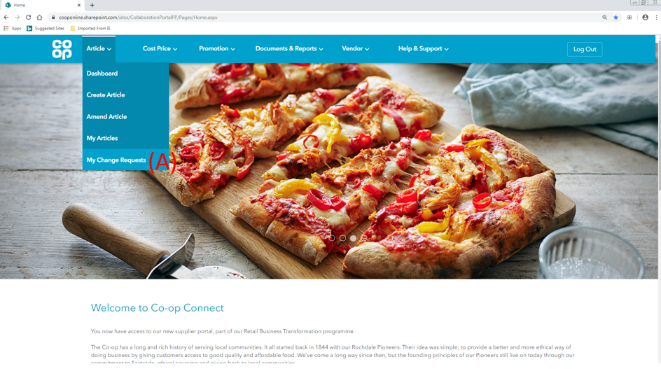
- Click on the ‘My Change requests’ option from the ‘Article’ menu in the main header

2.2. My Change Requests
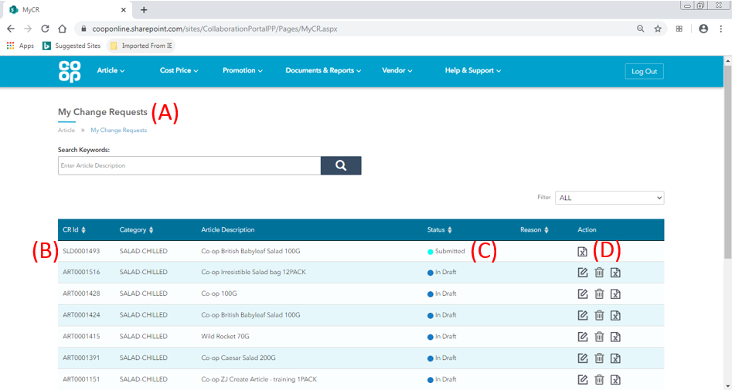
- My Change Requests – this screen will display all of the change requests for the following processes:
- Create Article
- Amend Article
- Shelf Life derogations

- CR Number – the change request number for create and amend change requests will begin with the letters ‘ART’. Find the amend article CR in the table.

- Status – This column shows the status of the change requests. Please see below for a full list of statuses with their descriptions:
Status | Description
Draft | The article CR has been started and saved, but not yet submitted. The buyer will only see the article CR once submitted.
Submitted | The article CR has been submitted and has not yet hit Co-op’s systems. This status should only show for a short period of time.
In Progress | The article CR has successfully hit our system and is now with the buyer for review.
Approved | The article CR has been approved by the buyer
Rejected | The article CR has been rejected by the buyer

- Actions – the action icons available for each change request will depend on the status the change request is in. A list of all icons are below:
Icon | Description | Available for change requests:
 | Bin Icon - Delete a change request proposal | In draft status only
 | Amend – amend the details of a change request | In draft status only
 | Extract – View the change request by exporting the information in to an excel document | In all statuses
 | Buyer notes – comments from the buyer on review | That have been in ‘sent for revision’ or ‘rejected’ status

Click on the extract icon to view a change request

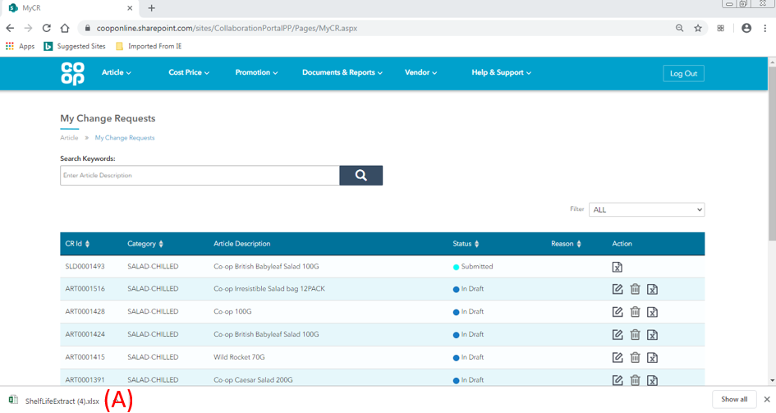
For Google Chrome users

- Excel download – once the print extract icon has been clicked, an excel version of the information will be downloaded on to the user’s computer. Click on this download to open the document in an excel file. This document can then be saved if required.

2.3. Extracted Form

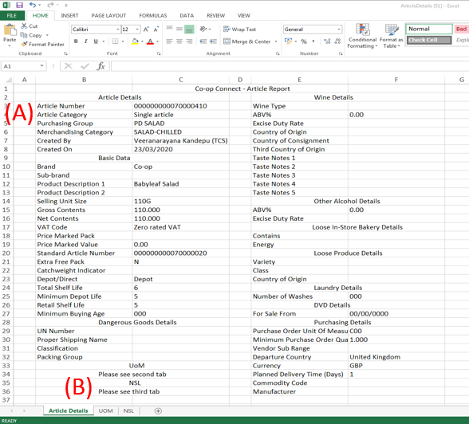
Once the downloaded file has been opened, the article information will be displayed in an excel format
- Article Details tab – for amend article CR’s, the information displayed will be a mixture of the current information that is held in SAP and the new information that has been amended/added by the Vendor for the CR.

The extract will show all of the fields in Co-op Connect. Some of the fields will be empty as they will not have been required for the type of article. E.g. Taste notes will be empty for a bakery article.

- Tabs – 3 tabs will be available:
- Article Details – the details from all tabs other than UoM and barcode linking
- UOM – the details from the Unit of Measure screen
- NSL – the details from the Barcode linking screen

