Co-op Connect Training
Scanback (On Issue): Create, view and recreate promotional funding proposals for a Scanback On issue fund category

Scanback On Issue Contents

1.0. Create fund – Scanback 3
Key points/ Top tips 3
1.1. Create Fund - Homepage 3
1.2. Create Funds 4
1.2.1. Create Fund – Scanback (on issue) 5
1.3. Add New Article 6
1.3.1. Add New Article Pop Up 7
1.4. Promotions Dashboard 8
2.0. View promotional funds 9
Key points/ Top tips 9
2.1. Homepage 9
2.2. My funds 9
2.3. View Fund 11
3.0. Recreate (copy) funding proposals 11
Key points/ Top tips 12
3.1. High level instructions – Recreate Promotional Funding Proposal 12
3.2. Recreate funds - Full guide 12
3.3. My Funds 13
3.4. View Funds 13
3.5. Recreate Funds – VF*** 14

1.0. Create fund – Scanback

Key points/ Top tips

- 4 types of fund can be created –
- Lumpsum – a onetime lumpsum given from Vendor to Co-op to promote selected products
- Scanback (on sale) – an amount of money given back to Co-op for every sale of selected articles in Co-op stores
- Scanback (on purchase) – an amount of money given back to Co-op on orders for selected articles over a period of time
- Scanback (On Issue) – an amount of money given back to Co-op for every order unit sent from depot to store during the promotional period. This fund category is only available for wine suppliers

This training guide will walk through how to create a Scanback On Issue fund

- Articles can be included in the same Scanback On Issue fund if they have the same:
- Fund type
- Fund category
- Amount
- Currency
- Promo calendar and period
- Buy-in date

- Previously submitted fund proposals can be copied in to a new ‘in draft’ proposal using the ‘Recreate’ function (please see section 3.0)

Create Fund - Homepage

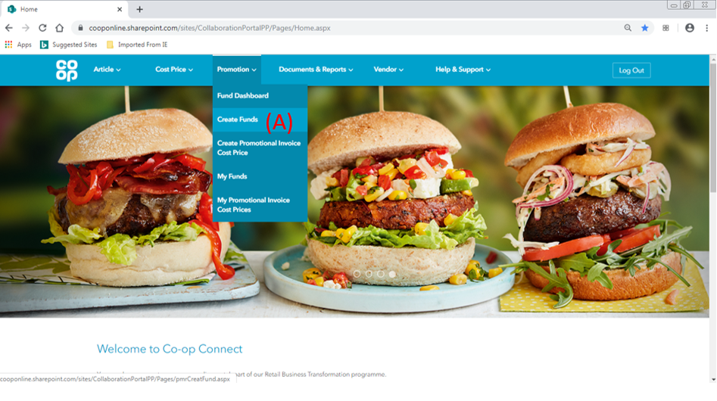

- Click on the ‘Create funds’ option from the ‘Promotions’ menu in the main header.

1.2. Create Funds

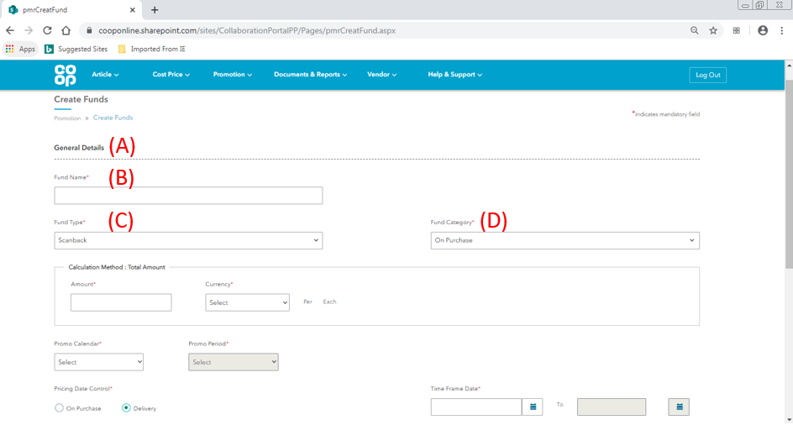
- General details – The page is split in to 2 sections:
- General details – the details of the fund are added first, including fund type and promo period
- Add article – the articles are added that the fund is in reference to

- Fund Name – Please enter a description which can be used to identify the fund. This will be attached to the fund and will displayed in SAP for the buyer to see, and also in the ‘My funds’ screen in Co-op Connect.

This field is capped to 30 characters. Please confirm with your buyer if they require a specific format.

- Fund type – Select the type of fund. 4 types of fund can be created:
- Lumpsum – a onetime lumpsum given from the Vendor to the Co-op to promote selected articles

- Scanback (on sale) – an amount of money given back to Co-op for every sale of selected articles in Co-op stores

- Scanback (on purchase) – an amount of money given back to Co-op on orders for selected articles over a period of time

- Scanback (On Issue) – an amount of money given back to Co-op for every order unit sent from depot to store during the promotional period. The on issue fund category is only available for wine suppliers.

1.2.1. Create Fund – Scanback (on issue)

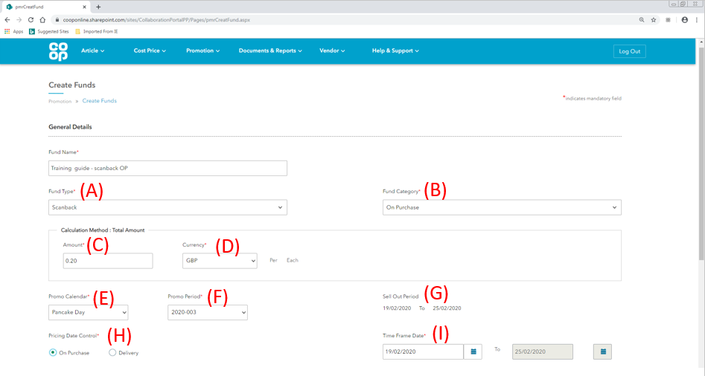
- Fund type – Once ‘Scanback’ has been selected as the fund type, the ‘Fund Category’ field will become available.

- Fund Category – There are 3 different categories for the scanback fund type, this example shows the fields for Scanback – On Issue.
Fund Category | Description
Scanback – on Issue | An amount of money given back to Co-op for every order unit sent from depot to store during the promotional period. The on issue fund category is only available for wine suppliers.

- Amount– please enter the amount of money that Co-op will get back for every order unit that is sent between depot and store during the promotional dates - per each/selling unit.

e.g. Co-op orders in cases of 10 selling units from a vendor. The agreement is for every case ordered the Co-op will receive £1 back.
The amount field = £0.10

- Currency – Please select the currency from the dropdown that the ‘amount’ field will be in terms of.

- Promo Calendar – Please select the promo calendar that the funding will be in relation to.

- Promo Period – once the promo calendar has been selected, the promo period field will become available. This will have a dropdown menu of all the promo periods associated with the selected promo calendar.

- Sell out period - Once the promo period has been selected, the ‘Sell Out Period’ time frame will appear. This will display the dates of the promo period.

- Pricing date control – for scanback on issue funds, the fund is driven by what is sent from the Co-op’s depot to store**. The pricing date control field shows whether the orders included in the fund will be based on when the order was purchased, or when the order was received by Co-op.

This field displays what has been previously agreed between vendor and buyer and is not amendable. For more information of changing vendor preferences, please see training material for ‘View/Amend Vendor details’.

The field will show 2 options:
- On Purchase - Orders that are purchased within the time frame date
- On Delivery – Orders that are received by the Co-op within the time frame date

- Time Frame date – using the calendar buttons, please select a period of time for the fund to be active based on the pricing date control setting.

Once all the fields have been populated, press the ‘Save’ button at the bottom of the page. This will save the draft to the ‘My Funds’ screen with the change request number shown at the top of the screen in the green success banner.

Add New Article

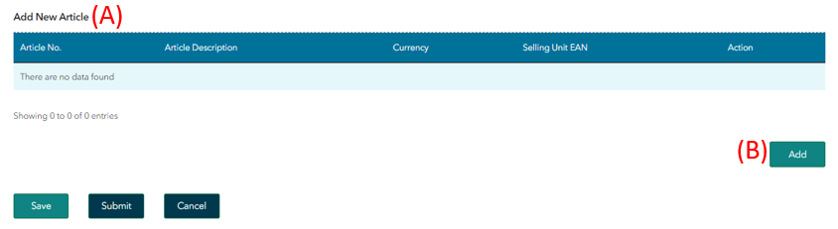
- Add New Article – this table will show the articles that are associated with the fund.

- Add Articles – to select the articles that will be associated with the fund, please click the ‘Add’ button.

1.3.1. Add New Article Pop Up

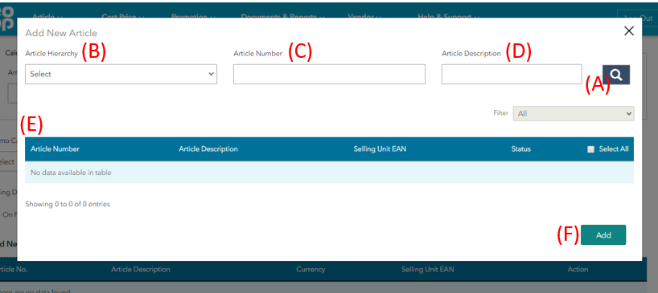
- Search – The article table in the pop-up window will be empty. Use one of the fields below and click the search bar to populate the table with articles:
- Article Hierarchy – please select an article hierarchy from the dropdown menu.
- Article number – search for an article by the SAP article number.
- Article description – search for articles by the description.
- Article table – Once one or the search fields has been populated, click the search button to populate the table with articles that meet the criteria. Select the articles that will be included in the fund.
- Add – Once the articles are selected, click the ‘Add’ button to add them to the fund.
When all of the details have been completed and the articles have been added to the fund, click ‘Submit’.

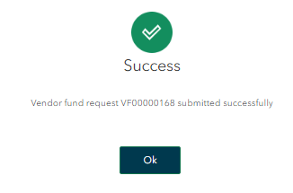

A success popup window will appear with the Change Request number for the fund - this will be in the format of: VF*******.
Pressing ‘OK’ will direct you to the dashboard screen for Promotional funds. The dashboard screen gives a high-level view of all the created funds in all statuses.

1.4. Promotions Dashboard

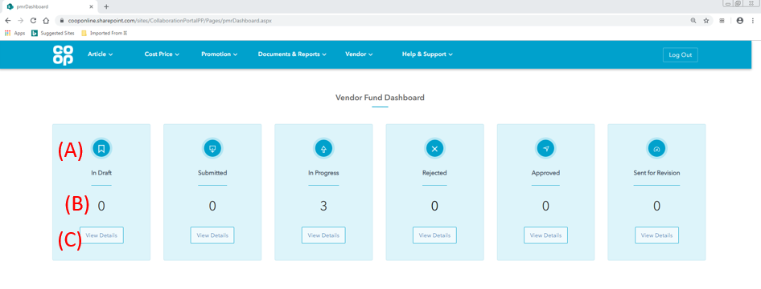
The dashboard screen gives a high-level view of all of the created funds in all statuses.
- Status - There will be six sections on the screen, each for a different status.

Status | Description
Draft | Funds that have been started and saved, but not yet submitted. The buyer will only see the fund once submitted.
Submitted | Funds that have been submitted and have not yet hit our systems. Funds should only be in submitted status for a short period of time.
In Progress | Funds that have successfully hit our system and are now with the buyer for review.
Approved | Funds that have been approved by the buyer.
Sent for Revision | Funds that have been sent back for revision by the buyer. These funds will need to be amended and resubmitted.
Rejected | Funds that have been rejected by the buyer.

- Quantity – the number of fund proposals that are in the status.

- View Details - Clicking on the ‘view details’ button on each status will take you through the ‘My funds’ screen, showing funds that are only in the selected status.

2.0. View promotional funds

Key points/ Top tips

- To view a fund, click on the ‘Fund ID’ in the ‘My Funds’ promotion screen.
- Submitted fund proposals will have the fund CR ID included in the fund name. For example:

2.1. Homepage

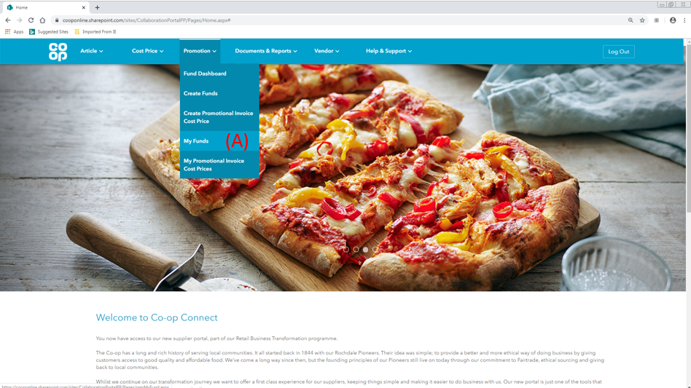
- Click on the ‘My Funds’ option from the ‘Promotions’ menu in the main header.

2.2. My funds

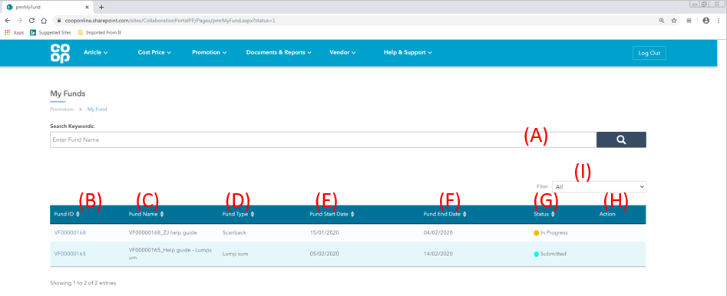
- Search Keywords – Search for a fund by fund name.
- Fund ID – This column displays the unique ID that is generated and associated to every promotional fund proposal. To view a fund proposal, click on its fund ID.

- Fund name – The Fund Name column displays the description that was attached to the fund by the user in the Fund Name field.

- For draft funds, this will be the Fund name that has been entered in the Fund Name field

- For funds that have been submitted, the Fund Name will automatically attach to the Fund CR ID. This column will display the Fund ID and the Fund Name together
- Fund Type – this column displays whether the fund is a Scanback or Lumpsum fund.
- Fund Start Date – the dates of the promo period only (shown in the ‘sell out period’ of the create fund screen).
- Fund End Date – the dates of the promo period (shown in the ‘sell out period’ of the create fund screen).
- Status – This column shows the status of the fund. Please see below for a full list of statuses with their descriptions:

Status | Description
Draft | The fund has been started and saved, but not yet submitted. The buyer will only see the fund once submitted.
Submitted | The fund has been submitted and has not yet hit our systems. This status should only show for a short period of time.
In Progress | The fund has successfully hit our system and is now with the buyer for review.
Approved | The buyer has approved the fund.
Sent for Revision | The buyer has sent the fund back for revision.
Rejected | The buyer has rejected the fund.

- Action – the action icons available for each proposal will be specific to the proposal. A list of all icons is below:
- Bin (draft status only) – delete a fund proposal
- Amend (draft and sent back for revision status only) – amend the details of a fund
- Filter – the list of funds can be filtered on their status. Select a status to filter the proposals available in the table.

10 funds can be displayed in the table on the screen at any one time. If more than 10 funds have been raised multiple pages will display.

2.3. View Fund

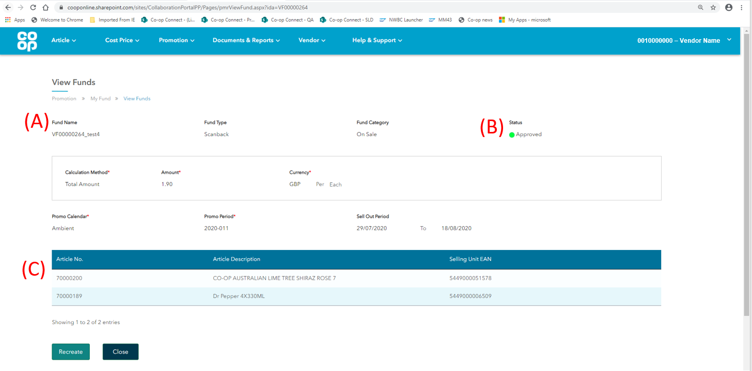
To view a promotional fund, click on the ‘Fund ID’ in the ‘My Funds’ screen. Once clicked, a screen similar the screenshot above will display.

- Fund name – the fund name will be a concatenation of the Fund ID and the Fund name that was given by the user during the fund’s creation.

- Status – the status that the fund proposal is currently in.

Status | Description
Draft | The fund has been started and saved, but not yet submitted. The buyer will only see the fund once submitted.
Submitted | The fund has been submitted and has not yet hit our systems. This status should only show for a short period of time.
In Progress | The fund has successfully hit our system and is now with the buyer for review.
Approved | The buyer has approved the fund.
Sent for Revision | The buyer has sent the fund back for revision.
Rejected | The buyer has rejected the fund.

- Article table – The article table shows all the articles that are attached to the fund proposal.

3.0. Recreate (copy) funding proposals
The recreate function has been deployed to help suppliers reduce the amount of time it takes to submit promotional funding and cost price proposals. Recreating a proposal will bring all the information of the previously submitted proposal in to a new ‘in draft’ proposal which can then be amended and submitted to the buyer.

Key points/ Top tips
- The recreate function can be used for both promotional funding (Create Fund) and standard cost price proposals (but not for ‘Promotional Invoice Cost price’ submissions)

- A proposal can be recreated by clicking on the CR number in the ‘My funds’ screen under the main ‘Promotions’ header

- Promotional funding proposals can be recreated if they are in one of the following statuses:
- In progress
- Approved
- Rejected

3.1. High level instructions – Recreate Promotional Funding Proposal
To copy the details of a previously submitted promotional funding proposal in to a new ‘in draft’ CR:
- Click on the ‘My Funds’ option under the main ‘Promotions’ header
- Click on the Fund ID number (beginning VF***) of the proposal you would like to recreate
- Scroll to the bottom of the page and click the ‘Recreate’ button
- Complete the details of the proposal that have not been copied/ amend any details needed
- Submit the cost price proposal to buyer for review

3.2. Recreate funds - Full guide

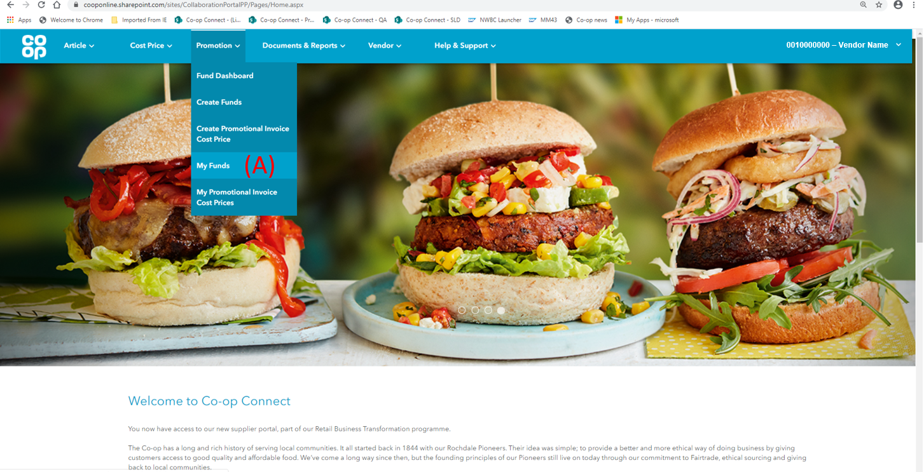
- Click on the ‘My Funds’ option under the main ‘Promotions’ header

3.3. My Funds

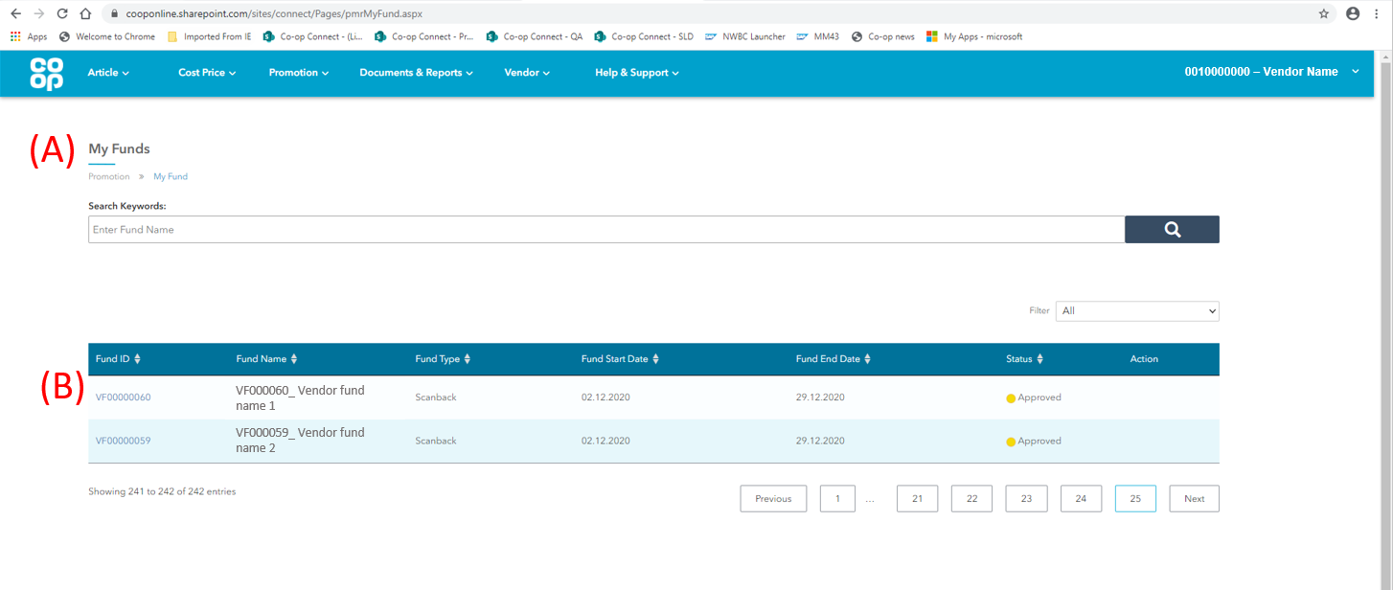
- My funds – the ‘My Funds’ screen displays all of the funding proposals that have been submitted by the Vendor across all users
- Fund ID – click on the Fund ID of the proposal that is to be recreated

Click on the CR number of a previously submitted fund proposal

3.4. View Funds

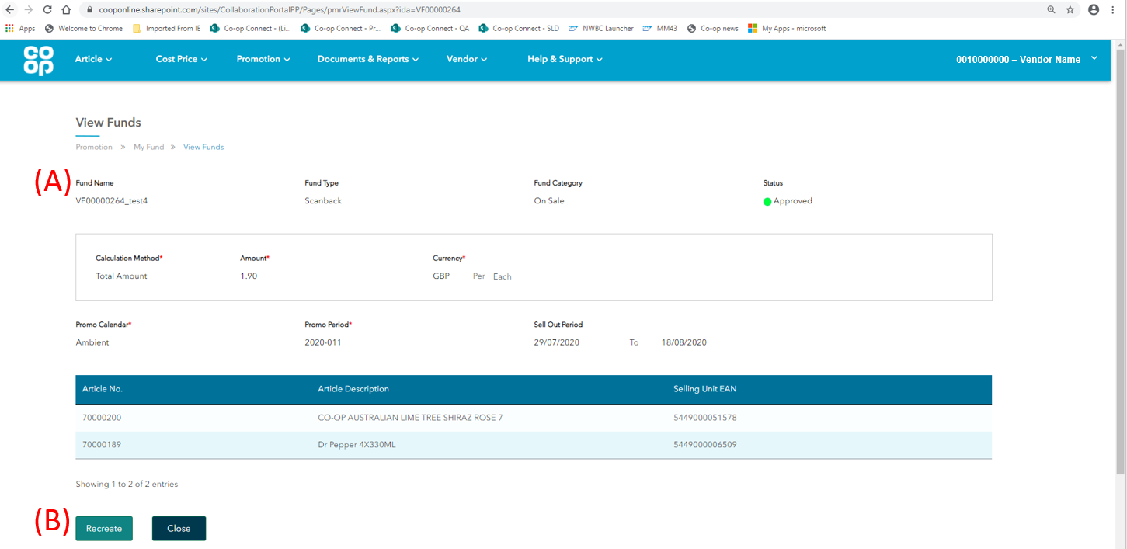
- Fund details – the screen will show the details of the previously submitted fund, these will be the details that are copied into a new proposal once ‘Recreate’ is clicked

- Recreate - the ‘Recreate’ button is at the bottom of the screen. Clicking on this button will open a new ‘in draft’ fund proposal, copying the following from the original CR:
- Fund type & category
- Amount & Currency
- Articles

3.5. Recreate Funds – VF***

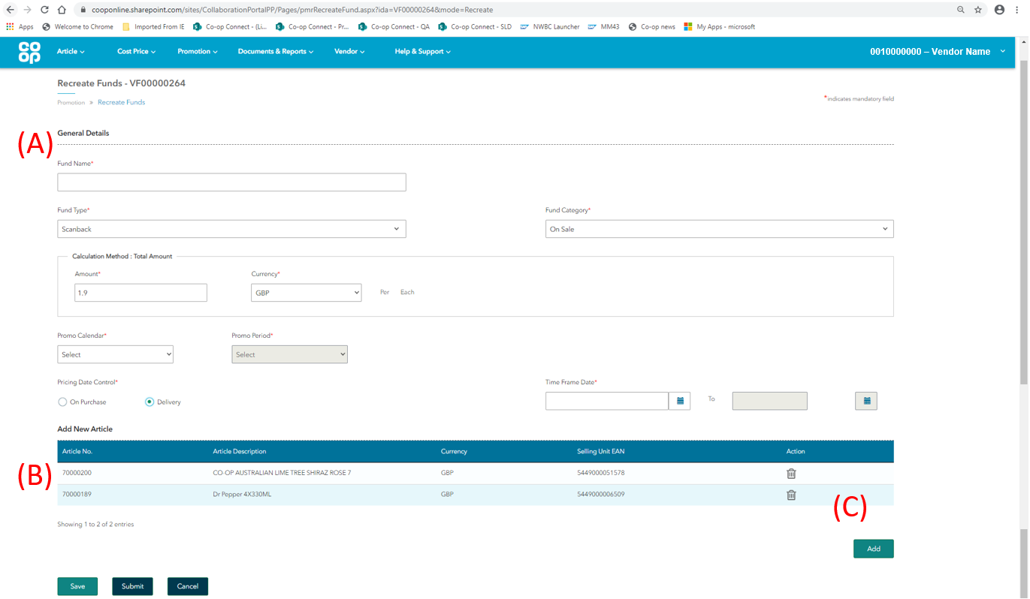
- Header level details – the following fields will not copy from the previous funding proposal and will need to be completed by the user before submission:
- Fund name
- Promo Calendar & Period
All the fields and details of the ‘in draft’ proposal can be amended before submission
- Article table – the units of the articles that were in the previous fund proposal will have copied through to the table. The articles attached to the recreated proposal can be amended

- Delete unit – the articles that have been copied into the new proposal can be amended:
- Units can be deleted using the bin icon
- New units can be added by clicking the ‘Add New Article’ button
Once all the details have been completed, the proposal can be submitted through to the buyer as a new proposal.

